Surveying Lab (CE-303)
Civil Engineering

EXPERIMENT NO.1
Drawing of signs and symbols on sheet
Date of conduction:-
Date of submission:-
Submitted by other members:-
1.
2.
3.
4.
5.

Group no:-

Signature

Name of faculty in charge:
Name of Technical Assistant:

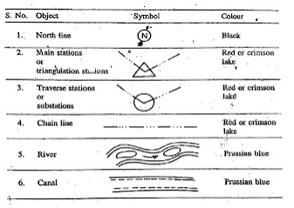

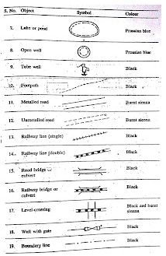
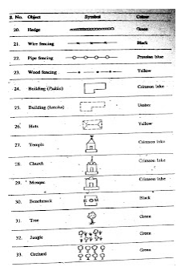

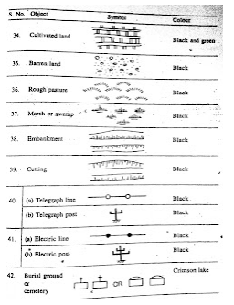

Surveying Lab (CE-303)
Civil Engineering

EXPERIMENT NO.2
Study of theodolite

Date of conduction:-
Date of submission:-
Submitted by other members:-
1.
2.
3.
4.
5.

Group no:-

Signature

Name of faculty in charge:
Name of Technical Assistant:

DESCRIPTION:-
The theodolite is the precise instrument designed for the measurement of horizontal angle and
vertical angle and has a wide applicability in surveying such as laying of horizontal angle,
locating points on line, prolonging survey lines, establishing grades, determining difference in
elevation, setting out curves etc.

PARTS OF A TRANSIT THEODOLITE:-
The telescope can be revolved through a complete revolution about its horizontal axis in a vertical plane.

A. Levelling head:-
1. A Levelling head consists of two parallel triangular plates known as tribrach plates.
2. The upper tribrach has three arms each carrying a Levelling screw.
3. The main functions of the Levelling head is,
(a) To support the main part of the instruments.
(b) To attach the theodolite to the tripod.
(c) To provide a mean for leveling the theodolite.
B. Telescope:-
1. It is mounted on a spindle known as horizontal axis or trunnion axis
C. Vertical circle:-
1. It is a circular arc attached to the trunnion axis.
2. By means of vertical clamp screw and tangent screw the telescope can be accurately set at any desired position in vertical plane.
3. The graduation in each quadrant is numbered from 0° to 90° in opposite directions.
D. Index Frame:-
1. At the two extremities, two Vernier are fitted to read the vertical axis.
2. When the telescope is moved in a vertical plane, the Vertical circle moves relative to the Vernier with the help of which reading can be taken.
3. A long sensitive bubble tube is placed on the top of the index frame.

E. Standards (or) A – Frame:-
1. This stands upon the Vernier plate to support the horizontal axis.
F. Two Spindles:-
1. The two axes have a common axis, which forms the vertical axis of the instruments.
G. Lower plate:-
1. It carries a horizontal circle graduated from 0° to 360° in a clockwise direction as silvered, beveled edge.
2. By means of clamp screw and tangent screw this can be fixed at any desired position.
H. Upper plate:-
1. It also carries clamp and tangent screw to accurately with the lower plate.
2. On clamping the upper clamp and unclamped lower clamp, the instrument can rotates on its outer axis without any relative motion between the two plates.
3. If the lower clamp is clamped and upper clamp unclamped, the upper plate and the instrument can rotate on the inner axis with a relative motion between the Vernier and the scale.
4. For using any tangent screw, its corresponding clamp screw, its corresponding clamp screw must be tightened.
I. Level tubes:-
1. This upper plate carries two level tubes placed at right angles to each other in which one is kept parallel to the trunnion axis.
2. Theses can be centered with the help of foot screws.
J. Plumb Bob:-
1. This is suspended from the hook fitted to the bottom of the inner axis to canter the instruments exactly over the station mark.

TEMPORARY ADJUSTMENTS:-
A. Setting over the station:-
1. Centre the instruments over the station marked by a plumb bob.
2. Level approximately with the help of tripod leg.
B. Levelling Up:-
1. Do these using three-foot screws similar to that of Levelling instrument.

C. Elimination of Parallax:-
1. By focusing the eyepiece for distinct vision of the cross hairs.
2. By focusing the objective to bring the image of the object in the plane of cross hairs.

IMPORTANT TERMS:-
1. Vertical Axis: - The axis about which the theodolite may be rotated in a horizontal plane.
2. Horizontal Axis: - The axis about which the telescope along with the vertical circle of a theodolite may be rotated in a vertical plane.
3. Axis of telescope: - The axis about which the telescope may be rotated is called axis of telescope.
4. Axis of the level tube: - The straight line that is tangential to longitudinal curve of the level at its centre is called axis of the level tube.
5. Centering: - The process of setting up theodolite exactly over the groundwork station is called known as centering.
6. Transiting: - The process of turning the telescope in vertical plane through 180° about its horizontal axis is called transiting.
7. Swing: - A continuous motion of the telescope about the vertical axis in horizontal plane is called swing the swing may be either in face left or right.
8. Face left observation: - The observation of angles when the vertical circle is on the left side of scope.
9. Face right observation: - The observations of angles when the vertical circle is on the right of the telescope.
10. Changing the face: - The operation of changing the face of telescope from right to left and vice-versa.
11. A set: - A set of horizontal observations of any angle consists of two horizontal measures one on the left face and other on the right face.
12. Telescope normal: - A telescope is said to be normal when its vertical circles is to its left and bubble of the telescope is up.

13. Telescope inverted: - A telescope is said to be inverted or reversed when its vertical circle is to its right and the bubble of the telescope is down.

Surveying Lab (CE-303)
Civil Engineering

EXPERIMENT NO.3
PLANE TABLE- RADIATION METHOD
Date of conduction:-
Date of submission:-
Submitted by other members:-
1.
2.
3.
4.
5.

Group no:-

Signature

Name of faculty in charge:
Name of Technical Assistant:

Aim: -To draw the position in plan of the given points by radiation method.
Equipment and Accessories:- Plane table and its accessories (tripod, alidate, trough compass, plumbing fork, spirit level, drawing sheet, cello- tape, pencil, eraser and dusting cloth), chain, tape, ranging rods, pegs, hammer and field-book.
Principle:- Plane table is a surveying instrument that can be used to prepare a map or plan of an area directly in the field without the direct measurement of any angles. Radiation is one of the methods employed in plane table survey. This method is generally employed for locating the details.
In this method, a ray is drawn from the instrument station towards the point. The distance is measured between the instrument station and the point. The point is located by plotting to some scale the distance so measured. This method is more suitable for small distances. One instrument station can cover several points to be detailed. Procedure:
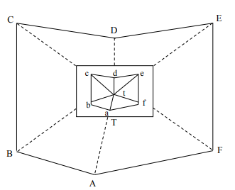
Fig.1 PLANE TABLE- RADIATION METHOD
1) Select a point ‘T’ on the ground so that all points to be located are visible from it.
2) Set up the table at ‘T’, level it, and do centering.
3) Transfer the point ‘T’ on to the drawing sheet by means of plumbing fork so that it is exactly over station ‘T’ on the ground and name it ‘t’.
4) Mark the direction of the magnetic meridian on the drawing sheet by means of trough compass.
5) Centering the alidade on ‘t’ BISECT the points A, B, C, D, E and F one after the other and draw the rays along the fiducial edge.
6) Measure the distances TA, TB, TC, TD, TE and TF on the ground and plot their distances to some scale along the corresponding rays and thus get the position of points a, b, c, d, e, and f on the drawing sheet. (upper case letters are used to represent stations on ground and lower case letters are used to represent stations on drawing sheet)
7) Join a,b,c,d,e and f on the drawing sheet.
Observations and Calculations: 1. Measure the distance AB, BC, CD, DE, EF and FA on the ground.
2. Scale the distance ab, bc, cd, de, ef and fa on the drawing sheet
Result:- Compare the ground and plan distances between the stations A, B, C, D, E and F.

Surveying Lab (CE-303)
Civil Engineering

EXPERIMENT NO.4
PLANE TABLE- INTERSECTION METHOD
Date of conduction:-
Date of submission:-
Submitted by other members:-
1.
2.
3.
4.
5.

Group no:-

Signature

Name of faculty in charge:
Name of Technical Assistant:

Aim:- To draw the position in plan of the given points by intersection method.
Equipment and Accessories:- Plane table and its accessories (tripod, alidate, trough compass, plumbing fork, spirit level, drawing sheet, cello- tape, pencil, eraser and dusting cloth), chain, tape, ranging rods, pegs, hammer and field-book.
Principle: Plane table is a surveying instrument that can be used to prepare a map or plan of an area directly in the field without the direct measurement of any angles. Intersection is one of the methods employed in plane table survey. This method is generally employed for locating the details.
In this method the location of an object is determined by sighting at the object from two plane table stations and drawing the rays. The intersection of these rays will give the position of the object. Therefore in this method it is essential to have at least two plane table stations. The distance between the two plane table stations is measured and plotted on the sheet to some scale. The line joining the two plane table stations is known as the base line. No linear measurement other than that of the base line is made in this method of surveying.
This method is preferred when the distance between the point and the plane table station is either too large or cannot be measured accurately due to some field conditions.
Procedure: It is required to plot the position of ground points PQRS (shown in figure given below) on the drawing sheet. The line AB is a base line measured on the ground. It is represented by the line ab on the board drawn to scale. The position of the base line AB is chosen such that it is in the middle of the boundary formed by PQRS.
1. Set up the plane table over A and orient the plane table by laying the alidade along the drawn line ab and rotate the board until B is sighted from A through the alidade (Now the line ab is aligned with line AB on the ground).
2. Pivot the alidade at ‘a’ and sight to the points P, Q, R & S and draw the rays. These rays represent the lines of sight to these features.
3. Shift the table to B. Plumb point b on the board over B on the ground.
4. By laying the alidade along the drawn line ba rotate the board until A is sighted and clamp the board (Now the line ab is aligned with line AB on the ground)
5. Mark the direction of the magnetic meridian on the drawing sheet by means of trough compass.
6. Pivot the alidade at ‘b’ and sight to the points P, Q, R & S and draw the rays (The rays from B will intersect those drawn from A, thus establishing the positions p, q, r and s on the board).
7. Join the points p, q, r & s on the drawing sheet
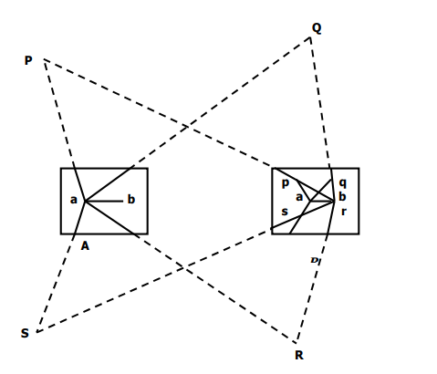
Fig.1 PLANE TABLE- INTERSECTION METHOD
Observations and Calculations:
1. Measure the distance PQ, QR, RS and SP on the ground.
2. Scale the distance pq, qr, rs and sp on the drawing sheet.
Result:- Compare the ground and plan distances between the stations P, Q, R and S

Surveying Lab (CE-303)
Civil Engineering
EXPERIMENT NO.5
PLANE TABLE- THREE POINT PROBLEM
Date of conduction:-
Date of submission:-
Submitted by other members:-
1.
2.
3.
4.
5.

Group no:-

Signature

Name of faculty in charge:
Name of Technical Assistant:

Aim: -To Locate the position on the plan, of the station occupied by the plane table by means of observations to three well defined points whose positions have been previously plotted on the plan.
Equipment and Accessories: -Plane table and its accessories (tripod, alidate, trough compass, plumbing fork, spirit level, drawing sheet, cello- tape, pencil, eraser and dusting cloth), chain, tape, ranging rods, pegs, hammer and field-book.
Principle:- Plane table is a surveying instrument that can be used to prepare a map or plan of an area directly in the field without the direct measurement of any angles. In the process sometimes a technique called ‘resection’ is employed.
Procedure:-
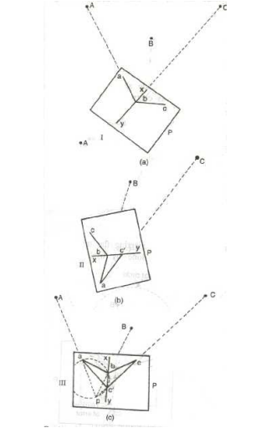
Fig.1 Three-point problem – plane table
Let us take three points A, B and C the plotted positions of which are known (a, b and c).
Let P be the point to be plotted. Therefore the whole problem is to orient the table at P.
1) After having set the table at station P, keep the alidade on ba and rotate the table so that A is bisected. Clamp the table.
2) Pivot the alidade about b, sight to C and draw the ray x y along the edge of the alidade.
3) Keep the alidade along ab and rotate the table till B is bisected. Clamp the table.
4) Pivot the alidade about a, sight to C. Draw the ray along the edge of the alidade to intersect the ray x y in c′. Join c c′.
5) Keep the alidade along c′c and rotate the table till C is bisected. Clamp the table. Now the table is correctly oriented.
6) Pivot the alidade about b, sight to B. Draw the ray to intersect c c′ in p. Similarly, if alidade is pivoted about a and A is sighted, the ray will pass through p if the work is accurate.
Note: The points a, b, c′ and p form a quadrilateral and all the four points lie along the circumference of a circle. Hence this method is known as “Bessel’s Method of Inscribed Quadrilateral”.
Observations and Calculations: 1. Measure the distance PA, PB and PC on the ground.
2. Scale the distance pa, pb and pc on the drawing sheet
Result:- Compare the ground distances PA, PB and PC with corresponding plan distances pa Pb and pc.

Surveying Lab (CE-303)
Civil Engineering
EXPERIMENT NO.6
To determine the multiplying and additional constants of a tachometer
Date of conduction:-
Date of submission:-
Submitted by other members:-
1.
2.
3.
4.
5.

Group no:-

Signature

Name of faculty in charge:
Name of Technical Assistant:

AIM: -To determine the Tacheometer constants
INSTRUMENT REQUIRED Tacheometer with tripod Pegs Levelling staff Arrows Tape
FORMULA :
Tacheometricequation
D = Ks+C
Where, K = Multiplying constant C = Additive constant S = staff intercept D = distance of peg points PROCEDURE :-
1. A line of fixed length is fixed on the ground and pegs are driven at some specified interval.
2. The instrument is set up at a convenient point from which all the pegs can be seen;
3. Temporary adjustments are made and the line of sight iskept horizontal.
4. Levelling staff is kept at peg fronts and staff intercept is noted down.
5. Knowing the staff intercept and distance, the tacheometric constants can be found by solving the tacheometric equations.
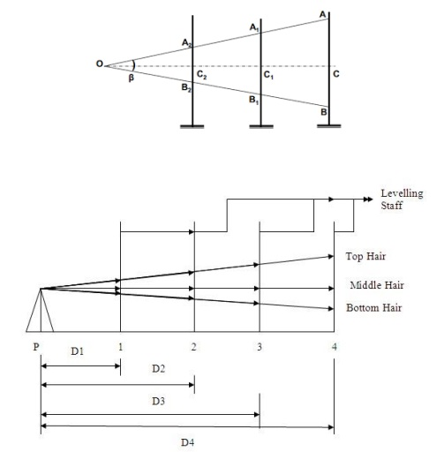
Fig-1
Instrument at | Staff at | Staff hair reading |  | Staff intercept | Distance (m)
Instrument at | Staff at | Top | Bottom | Staff intercept | Distance (m)

RESULT:- The constants of tachometer are
Multiplying constant K =
Additive Constant C =

Surveying Lab (CE-303)
Civil Engineering
EXPERIMENT NO.7
To determine the distance and elevation of a point using tacheometric stadia system
Date of conduction:-
Date of submission:-
Submitted by other members:-
1.
2.
3.
4.
5.

Group no:-

Signature

Name of faculty in charge:
Name of Technical Assistant:

Aim:- Determination of Elevation of points by Tachometric surveying.
Apparatus:- A tachometer with tripod, tape, levelling staff, wooden pegs, ranging rods etc.

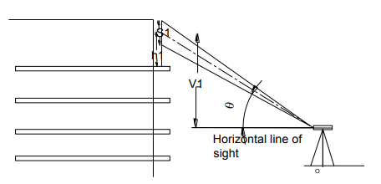
Formulae:- When line of sight is inclined and staff vertical then: θ θ sin 2 2 c Sin V = KS + θ + CSinθD = KSCos 2 Where, K= Multiplying constant =100 C= Additive constant S= Staff intercept. V =Vertical distance measured from horizontal line of straight to Central stadia hair reading on staff. H = Central stadia hair reading on staff. = vertical angleθ
Theory:- The Tachometry is an instrument which is generally used to determine the horizontal as well as vertical distance. It can also be used to determine the elevation of various points which cannot be determined by ordinary levelling. When one of the sight is horizontal and staff held vertical then the RLs of staff station can be determined as we determine in ordinary levelling .
But if the staff station is below or above the line of collimation then the elevation or depression of such point can be determined by calculating vertical distances from instrument axis to the central hair reading and taking the angle of elevation or depression made by line of sight to the instrument made by line of sight to the instrument axis.
Distance and Elevation formulae for vertical staff. Let P= Instrument station Q= Staff Station M= Position of instrument axis.
O= Optical centre of the objective. A, C, B= Point corresponding to the readings of the three hairs. S=AB= Staff intercept I =Stadia interval

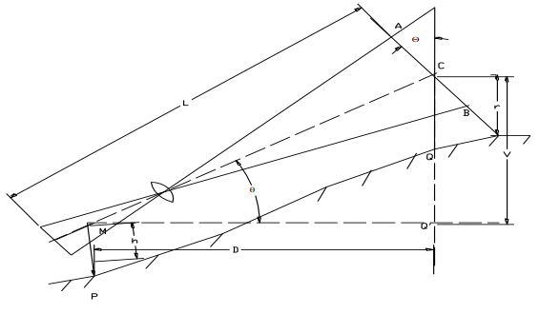
Fig.2- Inclined (elevation)
Ø= Inclination of the line of sight from the horizontal. L= Length MC measured along the line of sight. D=MQ’= Horizontal distance between the instrument and the staff. V= Vertical intercept, at Q between the line of sight and the horizontal line H= Height of the instrument R= Central hair reading β = Angle between the extreme rays corresponding to stadia hairs. Draw a line A’CB’ normal to the line of sight OC.
Similarly, from ΔCOB’, <CO’B = β/2
Since β/2, is very small (its value being equal to 17011’for K=100), <AA’C and <BB’C may be approximately taken equal to 90.
<AA’C = <BB’C =90.
From ^ ACA’AC=A’C=AC cosØ
A’B’=AB CosØ=s CosØ
Now, the horizontal distance D= LcosØ =(kscosØ+c)cosØ D=KScos2Ø+CcosØ---------------------------------(1) Similarly V= LsinØ (KS cosØ.+c )sinØ = KScosØ.sinØ+csinØ φ φ sin 2 sin V = KS + C ------------------------------------------------------(2) (a) Elevation of the staff station for angle of elevation If the line of sight has an angle of elevation Ø, as shown in fig. Elevation of staff station= Elevation of instrument + h + v – r (b) Elevation of the staff station for the angle of depression
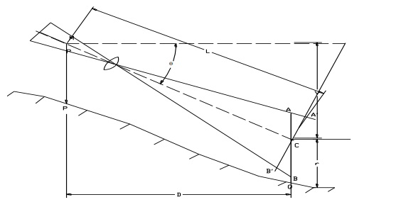

Fig.3- Inclined (elevation)
Elevation of Q= Elevation of P + h-v-r.
Procedure: -1) Set up the instrument in such a way that all the point should be visible from the instrument station.
2) Carryout the temporary adjustment and set vernier zero reading making line of sight horizontal.
3) Take the first staff reading on Benchmark and determine height of instrument.
4) Then sight the telescope towards the staff station whose R.Ls are to be calculated. Measure the angle on vernier if line of sight is inclined upward or downward and also note the three crosshair readings.
5) Determine the R.Ls of various points by calculating the vertical distance.
Instrument station | Staff station | Vertical angle | Stadia hair Reading |  |  | Remark
Instrument station | Staff station | Vertical angle | Top | Center | Bottom | Remark
A | BM
 | G. Floor
 | First Floor
 | Second Floor
 | Third Floor

Calculation:- θ + C cosθD = KS cos2 1) For ground floor:- θ)/2 + C sinθV1 = (K1S1sin2 2) R.L of ground floor = RL of BM + h + V1-h1

Result:- The RLs of Various points are found as follows

Sr. No | POINTS | R.Ls
1 | G Floor
2 | First Floor
3 | Second Floor
4 | Third Floor

Surveying Lab (CE-303)
Civil Engineering

EXPERIMENT NO.8

STUDY OF PLANIMETER

Date of conduction:-
Date of submission:-
Submitted by other members:-
1.
2.
3.
4.
5.

Group no:-

Signature

Name of faculty in charge:
Name of Technical Assistant:

APPARATUS:- Planimeter

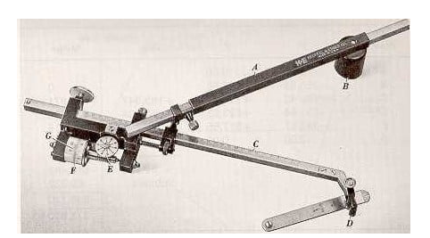

Fig1.Planimeter

Planimeter :-
A Planimeter is a mechanical integrator is used by engineer for measuring area of figure which is been plotted scale particularly when the boundaries are irregular are curved mathematically it is difficult to find the area of such irregular figures. Planimeter is largely used for finding the areas of contour in determining the capacity of storage server.

Construction:-
These are several types of Planimeter but the ampler polar Planimeter is in most common use & is described as-
It consists of two arms hinged at a point one is known is anchor arm & it is at fixed length. It has a needle point called the anchor point which is fixed in paper & hold in position by detachable small weight the other arm is called trussing arm. it carries a tracing point which is moved along the periphery of the figure of which the area is to be found out . Tracing arm is adjustable is length the tracing arm is set to position given by the manufacturer according to scale used the total normal displacement is measured b rolling wheel. The rolling wheel carries graduated drum divided into 100 parts. The vernier is provided to read 1/10th parts of the rolling wheel. The wheel is connected by gears is the counting disc. The counting disc measure one revolution at every 10 turns of the rolling wheel each complete reading is a figure of four digits. The zero of rolling wheel is apposite to the zero at veriner. Actually the marks of rise should be opposite to index mark due to imperfection of the wheel gear.

Instrument is equipped with magnifying lance to read vernier & a check bar or flat bar for testing the Planimeter.

Reading on Planimeter:-
Each complete reading on Planimeter is a figure of digits. Let the reading be 4.375 the first digit 4 is read on the disc the second digit 3 is read on the rolling wheel (main scale) the third digit 7 is read on the falling wheel (main scale) & the last is fourth digit 5 is read on the vernier scale beside the main scale of rolling wheel position of measuring unit (setting of tracing arm) the position of tracing arm is adjustable according to given position by the manufacture for the different scalar. The position of measuring unit will be vary from instrument to the index mark on the beveled edge of the tracing arm of the figure may be obtained directly in m2 or hectors by marking use of multiplying scale factor.

Method of using Planimeter:-
The Planimeter is used in determining the areas of the figure in 2 ways.
- By placing the anchor point outside the figure.
- By placing the anchor point inside the figure.

Procedure:-
- 1Set out the index arm on the tracing arm to the given scale as per manufactures instruction exactly b using clamp & fine motion screw. Stretch the sheet making free from wrinkle ness.
- Fixed the anchor point of firmly on paper inside & for small outside keep.
- Mark the points on the boundaries of the figure & set tracing arm exactly over it.
- Now take the initial reading i.e. the reading on dial & wheel & vernier.
- Move the tracing point along the periphery of the figure & stop at the starting point.
- While tracing point is moved note the number of times the zero index mark in clockwise & anticlockwise direction. Again take the reading of on dial wheel & vernier that will be final reading.
- The calculated area (A) = m (FR-IR +10N+C)
Where, M=multiplying constant which is different scales
N=number of times the zero of dial passes the fixed index mark use the +ve sign when moves clockwise & -ve sign moves anticlockwise.
C= constant of instrument supplied by manufacture & different for different scales & it is offset when anchor point is kept inside otherwise it is taken zero if it is kept outside.
FR = Final reading
IR = Initial reading
Area of the zero circles i.e. Mc is defined as the correction circle which is defined as a circle found the circumference at which if the tracing point is moved wheel will slide without rotation in a reading. This is possible when tracing arm is placed in such a position relative to the anchor of arm that the plane of the roller passes thought the anchored point the multiply constant of Planimeter is equal to the number of unit of area per revolution of the roller.
RESULT: – Planimeter has been used to measured irregular figure.

