**CE502 Transportation Engineering-II**

**Civil Engineering**

**EXPERIMENT NO.1**

# AGGREGATE CRUSHING VALUE TEST

**Date of conduction:-**

**Date of submission:-**

**Submitted by other members:-**

**1.**

**2.**

**3.**

**4.**

**5.**

**Group no:-**

**Signature**

**Name of faculty in charge:**

**Name of Technical Assistant:**

## OBJECTIVE-

1. To determine the aggregate crushing value of coarse aggregates
2. To assess suitability of aggregates for use in different types of road pavement

## PRINCIPLE-

The aggregate crushing value gives a relative measure of the resistance of an aggregate to crushing under a gradually applied compressive load. Crushing value is a measure of the strength of the aggregate. The aggregates should therefore have minimum crushing value.

## APPARATUS-

The apparatus of the aggregate crushing value test as per IS: 2386 (Part IV) – 1963 consists of:

1. A 15cm diameter open ended steel cylinder with plunger and base plate, of the general form and dimensions as shown in Fig
2. A straight metal tamping rod of circular cross-section 16mm diameter and 45 to 60 cm long, rounded at one end.
3. A balance of capacity 3kg, readable and accurate up to 1 g.
4. IS Sieves of sizes 12.5,10 and 2.36 mm
5. A compression testing machine capable of applying a load of 40 tonnes and which can be operated to give a uniform rate of loading so that the maximum load is reached in 10 minutes. The machine may be used with or without a spherical seating.
6. For measuring the sample, cylindrical metal measure of sufficient rigidity to retain its Form under rough usage and of the following internal dimensions:

Diameter 11.5 cm

Height 18.0 cm

## 

## Fig 1 AGGREGATE CRUSHING TEST APPARATUS

**PROCEDURE**

The test sample: It consists of aggregates sized 12.5 mm - 10.0 mm (minimum 3kg). The aggregates should be dried by heating at 100-110o C for a period of 4 hours and cooled.

1. Sieve the material through 12.5 mm and 10.0 mm IS sieve. The aggregates passing through 12.5 mm sieve and retained on 10.0 mm sieve comprises the test material.
2. The cylinder of the test shall be put in position on the base-plate and the test sample added in thirds, each third being subjected to 25 strokes with the tamping rod.
3. The surface of the aggregate shall be carefully levelled.
4. The plunger is inserted so that it rests horizontally on this surface, care being taken to ensure that the plunger does not jam in the cylinder
5. The apparatus, with the test sample and plunger in position, shall then be placed between the
6. plates of the testing machine.
7. The load is applied at a uniform rate as possible so that the total load is reached in 10 minutes. The total load shall be 40 tonnes.
8. The load shall be released and the whole of the material is removed from the cylinder and sieved on 2.36mm IS Sieve.
9. The fraction passing the sieve shall be weighed and recorded.

## OBSERVATION TABLE:-

|  |  |  |
| --- | --- | --- |
|  | **Sample I** | **Sample II** |
| Total weight of drysample taken= W1 gm |  |  |
| Weight of portion passing 2.36 mm sieve= W2 gm |  |  |
| Aggregate  crushing = (W2/W1)*100 Value (per cent) |  |  |

Aggregate Crushing Mean Value =

## REPORTING OF RESULTS

The mean of the two results shall be reported to the nearest whole number as the ‘aggregate crushing value’ of the size of the material tested.

## RESULT

Aggregate Crushing test value =

**CE502 Transportation Engineering-II**

**Civil Engineering**

**EXPERIMENT NO.2**

# DETERMINATION OF AGGREGATE IMPACT VALUE

**Date of conduction:-**

**Date of submission:-**

**Submitted by other members:-**

**1.**

**2.**

**3.**

**4.**

**5.**

**Group no:-**

**Signature**

**Name of faculty in charge:**

**Name of Technical Assistant:**

## OBJECTIVE

1. To determine the impact value of the road aggregates
2. To assess suitability of aggregates for use in different types of road pavement

## PRINCIPLE

The property of a material to resist impact is known as toughness. Due to movement of vehicles on the road the aggregates are subjected to impact resulting in their breaking down into smaller pieces. The aggregates should therefore have sufficient toughness to resist their disintegration due to impact. This characteristic is measured by impact value test. The aggregate impact value is a measure of resistance to sudden impact or shock, which may differ from its resistance to gradually applied compressive load.

## APPARATUS

The apparatus of the aggregate impact value test as per IS: 2386 (Part IV) – 1963 consists of:

1. A testing machine weighing 45 to 60 kg and having a metal base with a plane lower surface of not less than 30 cm in diameter. It is supported on level and plane concrete floor of minimum 45 cm thickness. The machine should also have provisions for fixing its base.
2. A cylindrical steel cup of internal diameter 102 mm, depth 50 mm and minimum thickness

6.3 mm.

1. A metal hammer p weighing 13.5 to 14.0 kg the lower end is cylindrical in shape, is 50 mm long, 100.0 mm in diameter, with a 2 mm chamfer at the lower edge and case hardened. The hammer should slide freely between vertical guides and be concentric with the cup. The free fall of the hammer should be within 380 ± 5 mm.
2. A cylindrical metal measure having internal diameter of 75 mm and depth 50 mm for measuring aggregates.
3. Tamping rod 10 mm in diameter and 230 mm long, rounded at one end.
4. A balance of capacity not less than 500 g, readable and accurate up to 0.1 g.

## PROCEDURE

1. Bring the impact machine to rest without wedging or packing up on the level plate, block or floor, so that it is rigid and the hammer guide columns are vertical.
2. Fix the cup firmly in position on the base of machine and place whole of the test sample in it and compact by giving 25 gentle strokes with tamping rod.
3. Raise the hammer until its lower face is 380 mm above the surface of the aggregate sample in the cup and allow it to fall freely on the aggregate sample.
4. Give 15 such blows at an interval of not less than one second between successive falls.
5. Remove the crushed aggregate from the cup and sieve it through 2.36 mm IS sieves
6. Until no further significant amount passes in one minute. Weigh the fraction passing the sieve to an accuracy of 1gm (W2). Also weigh the fraction retained in the sieve.
7. 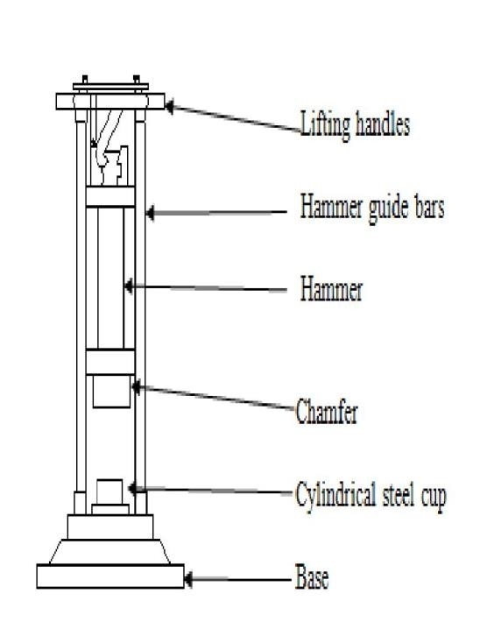Note down the observations in the Performa and compute the aggregate impact value. The mean of two observations, rounded to nearest whole number is reported as the Aggregate Impact Value.

## Fig 1 AGGREGATE IMPACT TESTING MACHINE

**OBSERVATION TABLE –**

|  |  |  |
| --- | --- | --- |
|  | **Sample I** | **Sample II** |
| Total Weight of Dry sample taken W1 gm |  |  |
| Weight of portion passing 2.36mm sieve  W2 gm |  |  |
| Aggregate impact value = (W2/W1)*100 |  |  |

**Aggregate Impact Mean Value =**

**REPORTING OF RESULTS**

The mean of the two results shall be reported to the nearest whole number as the aggregate impact value of the tested material. Aggregate impact value is used to classify the stones in respect of their toughness property as indicated below in Table 1.

|  |  |
| --- | --- |
| **Aggregate impact value (%)** | **Quality of aggregate** |
| < 10 | Exceptionally strong |
| 10 – 20 | Strong |
| 20 – 30 | Satisfactory for road surfacing |
| >35 | Weak for road surfacing |

## Table 1: Classification of aggregate based on aggregate impact value

|  |  |  |
| --- | --- | --- |
| **Sl.No** | **Types of pavement material /layer** | **Aggregate impact value (%)** |
| 1 | Water bound macadam, sub-base course | 50 |
| 2 | Cement concrete, base course | 45 |
| 3 | 1. WBM base coarse with bitumen surfacing 2. Built-up spray grout, base course | 40 |
| 4 | Bituminous macadam, base course | 35 |
| 5 | 1. WBM, surfacing course 2. Built-up spray grout, surfacing course 3. Bituminous penetration macadam 4. Bituminous surface dressing 5. Bituminous macadam, binder course 6. Bituminous carpet 7. Bituminous/Asphaltic concrete 8. Cement concrete, surface course | 30 |

**Table 2: Maximum allowable impact values of aggregate in different types of Pavement material/ layers**

**Aggregate Impact Mean Value = …………………**

**CE502 Transportation Engineering-II**

**Civil Engineering**

**EXPERIMENT NO.3**

# DETERMINATION OF LOS ANGELES ABRASION VALUE

**Date of conduction:-**

**Date of submission:-**

**Submitted by other members:-**

**1.**

**2.**

**3.**

**4.**

**5.**

**Group no:-**

**Signature**

**Name of faculty in charge:**

**Name of Technical Assistant:**

## OBJECTIVE

1. To determine Los Angeles abrasion value.
2. To find out the suitability of aggregates for its use in road construction.

## PRINCIPLE

The aggregates used in surface course of the highway pavements are subjected to wearing due to movement of traffic. When vehicles move on the road, the soil particles present between the pneumatic tyres and road surface causes abrasion of road aggregates. The steel reamed wheels of animal driven vehicles also cause considerable abrasion of the road surface. Therefore, the road aggregate should be hard enough to resist the abrasion. Resistance to abrasion of aggregates is determined in laboratory by Los Angeles test machine.

The principle of Los Angeles abrasion test is to produce the abrasive action by use of standard steel balls which when mixed with the aggregates and rotated in a drum for specific number of revolutions also causes impact on aggregates. The percentage wear of the aggregates due to rubbing with steel balls is determined and is known as Los Angeles Abrasion Value.

## APPARATUS

The apparatus as per IS: 2386 (Part IV) – 1963 consists of:

1. Los Angeles Machine: It consists of a hollow steel cylinder, closed at both the ends with an internal diameter of 700 mm and length 500 mm and capable of rotating about its horizontal axis. A removable steel shaft projecting radials 88 mm into cylinder and extending full length (i.e. 500 mm) is mounted firmly on the interior of cylinder. The shelf is placed at a distance 1250 mm minimum from the opening in the direction of rotation.
2. Abrasive charge: Cast iron or steel balls, approximately 48 mm in diameter and each weighing between 390 to 445 g; 6 to 12 balls are required.
3. Sieve: The 1.70 mm IS sieve
4. Balance of capacity 5 kg or 10 kg
5. Drying oven
6. 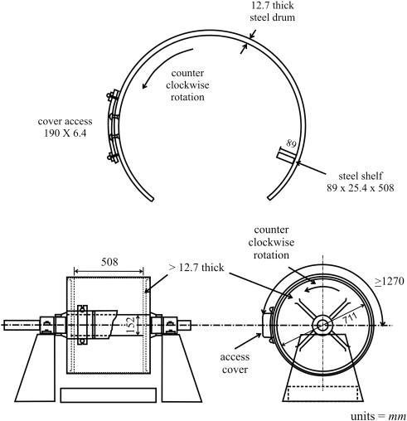Miscellaneous like tray etc

## Fig 1 LOS ANGELES ABRASION TESTING MACHINE

## Fig 1 LOS ANGELES ABRASION TESTING MACHINE

**PROCEDURE**

Test Sample: It consists of clean aggregates dried in oven at 105 - 110o C and is coarser than 1.70 mm sieve size.

*Tolerance of ±12 percent permitted.

1. Select the grading to be used in the test. It should be chosen such that it conforms to the grading to be used in construction, to the maximum extent possible.
2. Take 5 kg of sample for grading A, B, C or D and 10 kg for grading E, F and G.
3. Choose the abrasive charge as per Table 2.
4. The test sample and the abrasive charge shall be placed in the Los Angles abrasion testing machine.
5. The machine is rotated at a speed of 20 to 33 rev/min for grading A, B,C and D, the machine shall be rotated for 500 revolutions; for grading E, F and G, it shall be rotated for 1000 revolutions
6. The material is discharged from the machine after the completion of the test and is sieved through 1.7 mm IS sieve

|  |  |  |  |  |  |  |  |  |
| --- | --- | --- | --- | --- | --- | --- | --- | --- |
| Sieve siz (square hole) | | Weight in g of Test Sample for Grade | | | | | | |
| Passing On mm | Retained on mm | A | B | C | D | E | F | G |
| 80 | 63 | - | - | - | - | 2500* | - | - |
| 63 | 50 | - | - | - | - | 2500* | - | - |
| 50 | 40 | - | - | - | - | 5000* | 5000* | - |
| 40 | 25 | 1250 | - | - | - | - | 5000* | 5000* |
| 25 | 20 | 1250 | - | - | - | - | - | 5000* |
| 20 | 12.5 | 1250 | 2500 | - | - | - | - | - |
| 12.5 | 10 | 1250 | 2500 | - | - | - | - | - |
| 10 | 6.3 | - | - | 2500 | - | - | - | - |
| 6.3 | 4.75 | - | - | 2500 | - | - | - | - |
| 4.75 | 2.36 | - | - |  | 5000 | - | - | - |

## Table 1 Grading of Test Samples

|  |  |  |
| --- | --- | --- |
| **Grading** | **No. of Steel balls** | **Weight of charge, g** |
| A | 12 | 5000 ± 25 |
| B | 11 | 4584 ± 25 |
| C | 8 | 3330 ± 25 |
| D | 6 | 2500 ± 25 |
| E | 12 | 5000 ± 25 |
| F | 12 | 50005 |

**Table 2 Selection of Abrasive Charges**

## OBSERVATION TABLE

|  |  |  |
| --- | --- | --- |
|  | **Sample I** | **Sample II** |
| Total Weight of Dry sample taken W1 gm |  |  |
| Weight of portion passing 1.7 mm sieve W2 gm |  |  |
| Aggregate abrasion value = (W2/W1)*100 |  |  |

Los Angeles mean Abrasion value =

## REPORTING OF RESULTS

The difference between the original weight and the final weight of the test sample shall be expressed as a percentage of the original weight of the test sample. This value is reported as the percentage wear.

|  |  |  |
| --- | --- | --- |
| **Sl no.** | **Types of pavement layer** | **Maximum Los Angeles Abrasion**  **value (%)** |
| 1 | Water bound macadam ,sub-base course | 60 |
| 2 | 1. WBM base course with bituminous surfacing 2. Bituminous macadam base course 3. Built-up spray grout base course | 50 |
| 3 | 1. WBM surfacing course 2. Bituminous macadam binder course 3. Bituminous penetration macadam 4. Built-up spray grout binder course | 40 |
| 4 | i) Bituminous carpet surface course  ii Bituminous surface dressing, single or two coats  iii) Bituminous surface dressing, using pre-coated aggregates | 35 |
| 5 | i) Bituminous concrete surface course  ii Cement concrete pavement surface course | 30 |

**RESULT**

Los Angeles Value-

**CE502 Transportation Engineering-II**

**Civil Engineering**

**EXPERIMENT NO.4**

# DETERMINATION OF CALIFORNIA BEARING RATIO VALUE

**Date of conduction:-**

**Date of submission:-**

**Submitted by other members:-**

**1.**

**2.**

**3.**

**4.**

**5.**

**Group no:-**

**Signature**

**Name of faculty in charge:**

**Name of Technical Assistant:**

Aim: To determine the CBR value of a given soil sample.

## Theory:

The California Bearing Ratio (CBR) test is a penetration test which was developed by the California State Highway Department, USA for the evaluation of soil-sub grade strength and base course materials strength base course materials strength for flexible pavements.

The CBR is a measure of resistance of a material to penetration of a standard plunger under controlled density and moisture conditions at standard rate. CBR value as defined by IS: 2720 (Part XVI)-1979 is the ratio of the force per unit area required to penetrate a soil mass with a circular plunger of 50 mm diameter at the rate of 1.25 mm/minute, to that required corresponding penetration of a standard material. The CBR test may be controlled in remolded or undisturbed specimen in the laboratory. The test procedure should be strictly adhered if high degree of reproducibility is desired. Many methods exists today which utilize mainly CBR test values for designing pavements structure. The test is empirical and results cannot be related accurately with any fundamental property of the material. But the test is simple and has been extensively investigated for field correlations of flexible pavement thickness requirement.

**Equipment/Apparatus:** The apparatus as per IS:2720 (part XVI)-1979 comprises of the following:

1. *Loading machine*: Any compression machine with a capacity of at least 5000 kg which can operate at constant rate of 1.25mm per minute can be used for this purpose. A plunger of diameter 50mm, proving ring, deflection dial etc.
2. *Cylindrical moulds*: moulds of 150mm diameter and 175mmn height provided with a collar of about 50mm length and a detachable perforated base are used for this purpose. A spacer disk of 148mm and 47.7mm thickness is used to obtain a specimen of exactly 127.3mm height.
3. *Spacer disc*: A metal disc of 148 mm diameter and 47.7 mm height.
4. *Compaction rammer*: The material is compacted as specified for the work, either by dynamic compaction or static compaction. The details for dynamic compaction suggested by the ISI are given below:

|  |  |  |  |  |
| --- | --- | --- | --- | --- |
| Type of compaction | Number of layers | Weight of hammer, kg | Free fall, cm | Number of blows |
| Light compaction  Heavy compaction | 3  5 | 2.6  4.89 | 31  45 | 56  56 |

1. *Adjustable stem, perforated plate, tripod and dial gauge*: The standard procedure requires that the soil sample before testing should be soaked in water to measure swelling. For these purpose these accessories are required.
2. *Surcharge weights*: In order to simulate the effect of over lying pavement weight, one annular metal weights each of 2.5 kg and 147mm diameter are placed on top of the specimen, both at the time of soaking and testing the samples, as surcharge.
3. *Penetration plunger*: A metallic plunger having a diameter of 50 mm and at least 100 mm long.
4. IS sieve of sizes 20mm and 4.75mm, oven, balance, coarse filter etc. equipments are required.

## Line diagram:

**Fig 1.1:** Line diagram of CBR test apparatus

## Procedure:

1. *Preparation of test specimen*: As per the ISI, the CBR test may be performed on undisturbed soil specimen obtained by fitting a cutting edge to the mould or on remoulded specimens. The material used in the remoulded specimen shall pass a 20-mm IS sieve. About 20 to 45kg of material is sieved and dried through 20mm sieve. If there is noteworthy proportion of material retained on 20mm sieve, allowance for larger materials is made by replacing it by an equal weight of material passing 20mm sieve and 4.75mm sieve. The optimum moisture content and maximum dry density of soil are determined by adopting either IS light compaction (Proctor Compaction) or IS heavy compaction (Modified Proctor

Compaction) as per the requirement. In case the most of the sample pass through 4.75mm sieve, then the dry pulverized sample is sieved through 4.75mm sieve and the portion passing this sieve is only used for this test. Remolded soil specimen may be compacted either by static compaction or by dynamic compaction.

*Statically Compacted Specimen*: The batch of soil is mixed with water to give the required moisture content. The correct weight of moist soil to obtain the desired density is placed in the mould and compaction is attained by pressing the spacer disc using a compaction or jack.

*Dynamically Compacted Specimen:* A representative sample of the soil weighing approximately 5.5kg for granular soil and 4.5 to 5kg weight for fine grained soils is taken and mixed thoroughly with water up to the optimum moisture content or field moisture content if specified so. The spacer disc is placed at the bottom of the mould over the base plate and a coarse filter paper is placed over the spacer discs. The moist soil is to be compacted over this in the mould by compacting either the IS light compaction or the heavy IS compaction.

1. For IS light compaction, the soil to be compacted is divided into three equal parts, the soil is compacted into three equal layers, each of compacted thickness about 44mm by applying 56 evenly distributed blows of the 2.6kg rammer.
2. For IS heavy compaction, the soil is divided into five equal parts. The soil is compacted in five equal layers, each of compacted thickness about 26.5mm by applying 56 evenly distributed blows of the 4.89kg rammer. After compacting the last layer, the collar is removed and the excess soil above the top of the mould is evenly trimmed off by means of the straight edge. It is important to see if the excess soil is to be trimmed off while preparing each specimen is of thickness about 5mm; If not the weight of soil taken for compacting each specimen is suitably adjusted for repeat tests so that the thickness of the excess layer to be trimmed off is about 5mm. Any hole that develops on the surface due to removal of coarse particles during trimming may be patched up with smaller size materials. Three such compacted specimens are prepared for

The clamps are removed and the mould with the compacted soil is lifted leaving below the perforated base plate and spacer disc which is removed. The mould with the compacted soil is weighed. A filter paper is placed on the perforated base plate, the mould with compacted soil is inverted and placed in position over the base plate (such that the top of the soil sample is now placed over the base plate) and the clamps of the base plate are tightened. Another filter paper is placed on the top surface of the soil sample and the perforated plate with adjustable stem over it. Surcharge weight of 2.5 or 5kg weight are placed over the perforated plate and the whole mould with the weights is placed in a water for soaking such that water can enter specimen from both top and bottom. The swell measuring device consisting of the tripod and the dial gauge are placed on the top edge of the mould and the spindle of the dial gauge is placed touching the top of the adjustable

stem of the perforated plate (see fig.2). The initial dial gauge reading is recorded and the test is kept undisturbed in the water tank to allow soaking of the soil specimen for four full days or 96 hours. The final dial gauge reading is noted to measure the expansion or swelling of the specimen due to soaking.

1. The swell measuring assembly is removed, the mould is taken out of the water tank and the sample is allowed to drain in a vertical position for 15 minutes. The surcharge weights, the perforated plate with stem and the filter paper are removed. The mould with the soil sample is removed from the base plate and is weighed again to determine the weight of the water absorbed.
2. The mould with the specimen is clamped over the base plate and the same surcharge weights are placed on the specimen such that the penetration test could be conducted. The mould with the base [plate is placed under the penetration plunger of the loading machine. The penetration plunger is seated at the centre of the specimen and is brought in contact with the top surface of the soil sample by applying a seated load of 4kg.
3. The dial gauge of the proving ring (for load reading) and the penetration dial gauge reading are set to zero.
4. The load is applied through the penetration plunger at a uniform rate of 1.25mm per-minute by setting the gear at constant rate of 1.25mm/min.
5. The load reading are recorded at penetration readings of 0.0, 0.5, 1.0, 1.5, 2.0, 2.5, 3.0, 3.5, 4.0, 5.0, 7.5, 10.0 and 12.5mm. In case the load readings start decreasing before 12.5mm penetration, the maximum load value and the corresponding penetration value are recorded. After the final reading, the load is released and the mould is removed from the loading machine.
6. The proving ring calibration factor is noted so that the load dial values can be converted into load in kg also find the least count of penetration dial gauge reading to convert into mm.(The present our laboratory machine, the proving ring calibration factor =0.99kg/div., the deflection dial gauge L.C=0.01mm/div.)
7. About 50gm of soil is collected from the top three cm depth of the soil sample for the full determination of moisture content (w). Also weigh the mould with full soil and empty and determine dry density (*γd*).

Formula used in determination of *γd* =*γm* / (1+w/100) g/cc

Where, = wet density

=W-Wm/ Vm ,g/cc

W= Weight of mould with moist compacted soil in gm.

Wm= Weight of empty mould in gm.

Vm= Volume of the mould in cc.

N.B. - In case of unsoaked test, (i) and (ii) are performed.

## Precautions:

* 1. The holes of the base plate of the mould should not be blocked.

1. The surcharge weight should be aligned with the plunger so that the plunger penetrates freely into the soil.

## Formulae to calculate the expansion ratio and CBR value:

The swelling or expansion ratio is calculated from observation during the swelling test using this formula:

Expansion ratio= 100(df-dt)/h

Where df= Final dial gauge after soaking in mm.

dt = initial dial gauge reading before soaking in mm h= Initial height of the specimen in mm.

The CBR value is calculated from this formula,

CBR% = [Load carried by soil sample at 2.5 or 5mm penetration / Load carried by standard crushed stone at 2.5 or 5mm penetration] x 100

## Results:

The expansion ratio of soil due to soaking and other details of the test may be reported as given in the observation sheet. The CBR values at 2.5 and 5mm penetrations are calculated for each specimen from the corresponding graphs as shown in Fig.1.2. Generally the CBR value at 2.5mm penetration is higher and this value is adopted. However if the CBR value is obtained at 5mm penetration, the test is to be repeated to verify the results. If the value at 5mm is again higher than it is adopted as the CBR value of the soil sample. The average CBR value of three specimens is reported to the first decimal place.

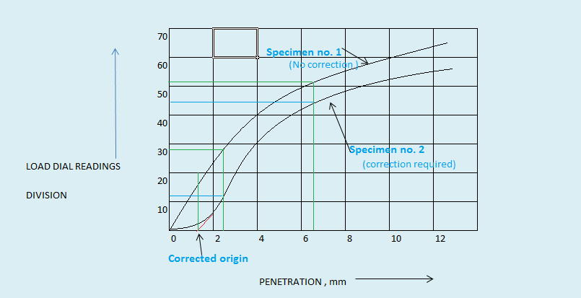

**Fig.1.2**: Typical load penetration curve

According to the Indian Road Congress, if the maximum variation in laboratory in CBR values between the three specimens exceed the value given below for the different ranges, the CBR test should be repeated on additional three specimens and the average value of six specimens is adopted.

|  |  |
| --- | --- |
| Maximum permissible variation in CBR values, % | Range of CBR values, % |
| 3.0  5.0  10.0  Not significant | Up to 10  10 to 30  30 to 60  Above 60 |

## Record of Observations:

Compaction moisture content = Dry density =

Condition of test specimen: soaked/unsoaked Moisture content: a) At top 3cm layer after soaking =

b) Average after soaking = Proving ring calibration factor =

Surcharge weight = Period

|  |  |  |  |  |  |
| --- | --- | --- | --- | --- | --- |
| Sample no.  (1) | Dial gauge reading in div.  (2) | Penetration in mm  (3) | Proving ring dial gauge reading in div.  (4) | Load on plunger in kg  (5) | CBR value at  2.5 and 5mm from graph  (6) |
| 1 | 0 | 0 |  |  | CBR at |
|  | 50 | 0.5 | 2.5mm= |
|  | 100 | 1.0 |  |
|  | 150 | 1.5 |  |
|  | 200 | 2.0 | CBR at |
|  | 250 | 2.5 | 5mm= |
|  | 300 | 3.0 |  |
|  | 400 | 4.0 |  |
|  | 500 | 5.0 |  |
|  | 750 | 7.5 |  |
|  | 1000 | 10.0 |  |
|  | 1250 | 12.5 |  |

Average CBR value at penetration 2.5 mm = % Average CBR value at penetration 5 mm = % CBR of the sample ( to be adopted for design) = %

Results: The mean CBR value of the three samples is the CBR value of the sub grade.

**CE502 Transportation Engineering-II**

**Civil Engineering**

**EXPERIMENT NO.5**

# DETERMINATION OF PENETRATION VALUE OF BITUMEN

**Date of conduction:-**

**Date of submission:-**

**Submitted by other members:-**

**1.**

**2.**

**3.**

**4.**

**5.**

**Group no:-**

**Signature**

**Name of faculty in charge:**

**Name of Technical Assistant:**

## OBJECTIVE

To determine the consistency of bituminous material

## PRINCIPLE

Penetration value is a measurement of hardness or consistency of bituminous material. It is the vertical distance traversed or penetrated by the point of a standard needle in to the bituminous material under specific conditions of load, time, and temperature. This distance is measured in one tenth of a millimeter. This test is used for evaluating consistency of bitumen. It is not regarded as suitable for use in connection with the testing of road tar because of the high surface tension exhibited by these materials and the fact that they contain relatively large amount of free carbon.

## APPARATUS

* 1. Container A flat bottomed cylindrical metallic dish 55 mm in diameter and 35 mm in depth is required. If the penetration is of the order of 225 or more deeper dish of 70 mm diameter and 45 mm depth is required.
  2. Needle: A straight, highly polished, cylindrical hard steel rod, as per standard dimensions
  3. Water bath: A water bath maintained at 25.0±0.10C containing not less than 10 litres of water, the sample being immersed to a depth not less than 100 mm from the top and supported on a perforated shelf not less than 50 mm from the bottom of the bath.
  4. Transfer dish or tray: It should provide support to the container and should not rock the container. It should be of such capacity as to completely immerse the container during the test.
  5. Penetration apparatus: It should be such that it will allow the needle to penetrate without much friction and is accurately calibrated to give results in one tenth of a millimetre
  6. Thermometer: Range 0- 440 C and readable up to 0.20C
  7. Time measuring device: With an accuracy ± 0.1 sec

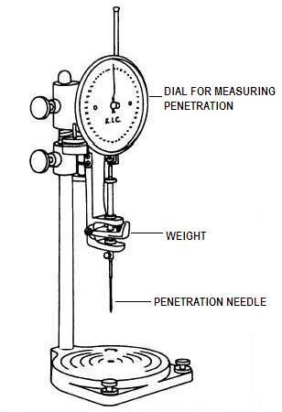

## Fig 1. PENETROMETER

**PROCEDURE**

1. Preparation of test specimen: Soften the material to a pouring consistency at a temperature not more than 600C for tars and 900C for bitumen’s above the approximate softening point and stir it thoroughly until it is homogeneous and is free from air bubbles and water. Pour the melt into the container to a depth at least 10 mm in excess of the expected penetration. Protect the sample from dust and allow it to cool in an atmosphere at a temperature between 15 to 300C for one hour. Then place it along with the transfer dish in the water bath at 25

±0.10C, unless otherwise stated.

1. Fill the transfer dish with water from the water bath to depth sufficient to cover the container completely, place the sample in it and put it upon the stand of the penetration apparatus.
2. Clean the needle with benzene, dry it and load with the weight. The total moving load required is 100 0.25gms, including the weight of the needle, carrier and super-imposed weights.
3. Adjust the needle to make contact with the surface of the sample. This may be done by placing the needle point in contact with its image reflected by the surface of the bituminous material
4. Make the pointer of the dial to read zero or note the initial dial reading.
5. Release the needle for exactly five seconds
6. Adjust the penetration machine to measure the distance penetrated.
7. Make at least 3 readings at points on the surface of the sample not less than 10 mm apart and not less than 10 mm from the side of the dish. After each test return the sample and transfer dish to the water bath and wash the needle clean with benzene and dry it . In case of material of penetration greater than 225, three determinations on each of the two identical test specimens using a separate needle for each determination should be made, leaving the needle in the sample on completion of each determinations to avoid disturbance of the specimen.

## OBSERVATION TABLE:

Actual Test Temperature =

|  |  |  |  |  |  |
| --- | --- | --- | --- | --- | --- |
|  | | Test 1 | Test 2 | Test 3 | Mean |
| Penetrometer  dial reading | Initial |  |  |  |
| Final |  |  |  |
| Penetration value | |  |  |  |  |

Penetration value =

## RESULT

Penetration value of given sample is =

**CE502 Transportation Engineering-II**

**Civil Engineering**

**EXPERIMENT NO.7**

# DETERMINATION OF SOFTENING OF BITUMINOUS MATERIAL

**Date of conduction:-**

**Date of submission:-**

**Submitted by other members:-**

**1.**

**2.**

**3.**

**4.**

**5.**

**Group no:-**

**Signature**

**Name of faculty in charge:**

**Name of Technical Assistant:**

## OBJECTIVE

To determine the softening point of bitumen or tar

## PRINCIPLE

The softening point of bitumen or tar is the temperature at which the substance attains a particular degree of softening. As per IS:334-1982, it is the temperature (in oC) at which a standard ball passes through a sample of bitumen in a mould and falls through a height of 2.5 cm, when heated under water or glycerin at specified conditions of test. The binder should have sufficient fluidity before its applications in road uses. The determination of softening point helps to know the temperature up to which a bituminous binder should be heated for various road use applications. Softening point is determined by ring and ball apparatus.

## APPARATUS

1. Steel balls-two numbers each of 9.5 mm dia. and weighing 3.5 0.05g.
2. Brass rings-two numbers each having depth of 6.4 mm. The inside diameter at bottom and top is 15.9 mm and 17.5 mm respectively.
3. Ball guides to guide the movement of steel balls centrally.
4. Support- that can hold rings in position and also allows for suspension of a thermometer. The distance between the bottom of the rings and the top surface of the bottom plate of the support is 25 mm.
5. Thermometer that can read up to 100oC with an accuracy of 0.2o C
6. Bath- A heat resistant glass beaker not less than 85 mm in diameter and 1220 mm in depth.
7. Stirrer.

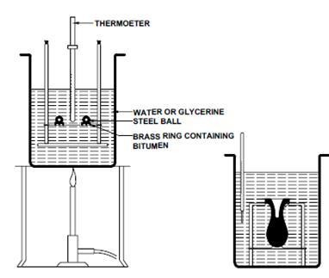

## Fig 1 ASSEMBLY OF APPARATUS FOR DETERMINATION OF SOFTENING

POINT (RING & BALL )

**PROCEDURE**

1. Heat the material to a temperature between 75-1000C above its softening point stir until, it is completely fluid and free from air bubbles and water. If necessary filter it through IS Sieve 30. Place the rings, previously heated to a temperature approximating to that of the molten material, on a metal plate which has been coated with a mixture of equal parts of glycerin and dextrin. After cooling for 30 minutes in air, level the material in the ring by removing the excess with a warmed, sharp knife.
2. Assemble the apparatus with the rings, thermometer and ball guides in position.
3. Fill the bath with distilled water to a height of 50 mm above the upper surface of the rings. The starting temperature should be 5oC .

Note: Use glycerin in place of water if the softening point is expected to be above 80 o C the starting temperature may be kept 35o C.

1. Apply heat to the bath and stir the liquid so that the temperature rises at a uniform rate of 5±0.5oC per minute.
2. As the temperature increases the bituminous material softens and the ball sinks through the ring, carrying a portion of the material with it.
3. Note down the temperature when any of the steel ball with bituminous coating touches the bottom plate.
4. Record the temperature when the second ball also touches the bottom plate. The average of the two readings to the nearest 0.5oC is reported as the softening point.

## OBSERVATION TABLE

|  |  |  |  |
| --- | --- | --- | --- |
| Temperature at which bitumen touches the ball in  °C | Ball no 1 | Ball No. 2 | Average |
|  |  |  |

**RESULT**

The softening point of given sample is =

**CE502 Transportation Engineering-II**

**Civil Engineering**

**EXPERIMENT NO.8**

# DETERMINATION OF DUCTILITY OF BITUMEN

**Date of conduction:-**

**Date of submission:-**

**Submitted by other members:-**

**1.**

**2.**

**3.**

**4.**

**5.**

**Group no:-**

**Signature**

**Name of faculty in charge:**

**Name of Technical Assistant:**

## OBJECTIVE

To determine the ductility of bitumen sample.

## PRINCIPLE

The ductility test gives a measure of adhesive property of bitumen and its ability to stretch. In a flexible pavement design, it is necessary that binder should form a thin ductile film around the aggregates so that the physical interlocking of the aggregates is improved. Binder material having insufficient ductility gets cracked when subjected to repeated traffic loads and it provides pervious pavement surface. Ductility of a bituminous material is measured by the distance in centimeters to which it will elongate before braking when two ends of standard briquette specimen of the material are pulled apart at a specified speed and at a specified temperature.

## APPARATUS

1. Briquette mould: It is made up of brass. The circular holes are provided in the clips to grip the fixed and movable ends of the testing machine. The moulds when properly assemble form a briquette specimen of the following dimensions.

Total length 75.0 ± 0.5 mm

Distance between clips 30.0 ± 0.3 mm Width at mount of slip 20.0 ± 0.2 mm

Width at minimum cross-section (half way between clips) 10.0 ± 0.1 mm Thickness throughout 10.0 ± 0.1mm

1. Water bath. A bath maintained within ±0.1oC of the specified test temperature, containing not less than 10 litres of water, the specimen being submerged to a depth of not less than 10 cm and supported on a perforated shelf and less than 5 cm from the bottom of the bath.
2. Testing machine. For pouring the briquette of bituminous material apart, any apparatus may be used which is so constructed that the specimen will be continuously submerged in water while the two clips are being pulled apart horizontally at a uniform speed of 50 ± 2.5 mm per minute.

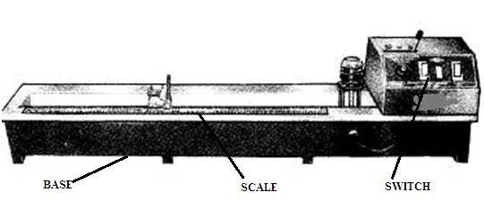

## Fig 1 DUCTILITY TESTING MACHINE

**PROCEDURE**

1. Melt the bituminous test material completely at a temperature of 750 C to 1000C above the approximate softening point until it becomes thoroughly fluid.
2. Strain the fluid. Through IS sieve 30.
3. After stirring the fluid, pour it in the mould assembly and place it on a brass plate.
4. In order to prevent the material under test from sticking, coat the surface of the plate and interior surfaces of the sides of the mould with mercury or by a mixture of equal parts of glycerine and dextrin.
5. After about 30-40 minutes, keep the plate assembly along with the sample in a water bath. Maintain the temperature of the water bath at 27 OC for half an hour.
6. Remove the sample and mould assembly from the water bath and trim the specimen by levelling the surface using a hot knife.
7. Replace the mould assembly in water bath maintained at 27O C for 80 to 90 minutes.
8. Remove the sides of the mould.
9. Hook the clips carefully on the machine without causing any initial stain.
10. Adjust the pointer to read zero.
11. Start the machine and pull two clips horizontally at a speed of 50 mm per minute.
12. Note the distance at which the bitumen thread of specimen breaks.
13. Record the observations in the Performa and compute the ductility value. Report the mean of two observation, rounded to nearest whole number as the ‘Ductility Value’

Note: machine may have a provision to fix two or more moulds so as to test these specimens simultaneously.

## OBSERVATION TABLE

Bitumen grade =

|  |  |  |  |  |
| --- | --- | --- | --- | --- |
| Reading | Briquette No | | | Mean |
| 1 | 2 | 3 |
| Initial |  |  |  |
| Final |  |  |  |
| Ductility in cm |  |  |  |  |

## RESULT

The ductility value of given sample is =

**CE502 Transportation Engineering-II**

**Civil Engineering**

**EXPERIMENT NO.9**

# DETERMINATION OF FLASH AND FIRE POINT OF BITUMEN

**Date of conduction:-**

**Date of submission:-**

**Submitted by other members:-**

**1.**

**2.**

**3.**

**4.**

**5.**

**Group no:-**

**Signature**

**Name of faculty in charge:**

**Name of Technical Assistant:**

## OBJECTIVE

To determine the flash and fire point for the given bituminous sample

## PRINCIPLE

The flash point of a material is the lowest temperature at which the application of test flame causes the vapors from the material momentarily catches fire in the form of a flash under specified conditions of test.

The fire point is the lowest temperature at which the application of test flame causes the material to ignite and burn at least for 5s under specified conditions of test.

## APPARATUS

1. Open Cup Tester is same as standard Pensky-Marten tester with the modification that cover of the cup is replaced by a clip which encircles the upper rim of the cup and carries a test flame
2. Thermometer
3. A stove / heating device with provision to adjust the rate of heating

## PROCEDURE

1. All the parts of the open cup tester and the accessories are cleaned and dried.
2. The cup is filled with the sample of bituminous binder up to the level of the filling mark.
3. The clip supporting the thermometer and test flame is placed in position on the cup.
4. The thermometer is inserted and the open cup tester is set on the stove.
5. The test flame is lighted and adjusted to size 4 mm bead and it is fixed in the vertical axis of the cup, level with the upper edge of the cup.

The bitumen sample in the tester is heated and the rate of heating is adjusted such that the temperature of the test specimen increases at the rate of 5°C to 6°C per minute

1. A burning match stick is placed at the binder surface from time to time and the appearance of flash, if any, is observed.
2. When the flash occurs the first time, the temperature at that instance is recorded as the flash point.

**REPORTING OF RESULTS**

The temperature of the binder when flash first appears at any point on the surface of the material is noted and recorded as the flash point under open cup flash point test.

The heating is continued at the same rate until the binder itself gets ignited and continues to burn for five seconds. When it occurs, the temperature of the material is noted and is recorded as the fire point.

## RESULT

Flash point =

Fire point =

**CE502 Transportation Engineering-II**

**Civil Engineering**

**EXPERIMENT NO.13**

# DETERMINATION OF SHAPE TEST ON AGGREGATE

**Date of conduction:-**

**Date of submission:-**

**Submitted by other members:-**

**1.**

**2.**

**3.**

**4.**

**5.**

**Group no:-**

**Signature**

**Name of faculty in charge:**

**Name of Technical Assistant:**

## FLAKINESS INDEX

**OBJECTIVE**

This method of test lays down the procedure for determining the flakiness index of the coarse aggregate.

## PRINCIPLE

The flakiness index of an aggregate is the percentage by weight of particles in it whose least dimension (thickness) is less than three-fifths of their mean dimension. The test is not applicable to sizes smaller than 6.3mm.

## APPARATUS

The apparatus shall consist of the following:

* 1. A balance – The balance shall be of sufficient capacity and sensitivity and shall have an accuracy of 0.1 percent of the weight of the test sample
  2. Metal Gauge – The metal gauge shall be of the pattern as shown in Fig 4
  3. Sieves – The sieves of sizes as shown in Table 6.

## PROCEDURE

1. A quantity of aggregate shall be taken sufficient to provide the minimum number of 200 pieces of any fraction to be tested.
2. The sample shall be sieved with sieves specified in Table 1.
3. Then each fraction shall be gauged in turn for thickness on a metal gauge of the pattern shown in Fig 1 or in bulk on sieves having elongated slots. The width of the slot used in the gauge or sieve shall be of the dimensions specified in column 3 of Table 1 for the appropriate size of material.
4. The total amount of aggregate passing the gauge shall be weighed to an accuracy of at least

0.1 percent of the weight of the test sample

## Table 1 Dimensions of Thickness and Length gauge

|  |  |  |  |
| --- | --- | --- | --- |
| **SIZE OF AGGREGATE (mm)** | | **THICKNESS GAUGE (mm)** | **LENGTH GAUGE (mm)** |
| **Passing through**  **IS Sieve** | **Retained on IS**  **sieve** |  |  |
| 63 | 50 | 33.90 | - |
| 50 | 40 | 27.00 | 81.0 |
| 40 | 31.5 | 19.50 | 58.5 |
| 31.5 | 25 | 16.95 | - |
| 25 | 20 | 13.50 | 40.5 |
| 20 | 16 | 10.80 | 32.4 |
| 16 | 12.5 | 8.55 | 25.6 |
| 12.5 | 10 | 6.75 | 20.2 |
| 10 | 6.3 | 4.89 | 14.7 |

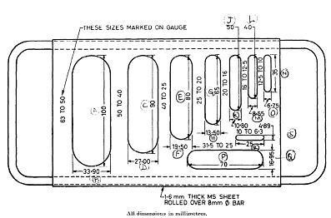*This dimension is equal to 0.6 times the mean sieve size. This dimension is equal to 1.8 times the mean sieve size.

## Fig 1. THICKNESS GAUG

\

**CALCULATION**

Flakiness index =w/W* 100 %

Where, *w* is the weights of material passing the various thickness gauges and W is the total weights of aggregate passing and retained on the specified sieves.

## REPORTING OF RESULTS

The flakiness index is the total weight of the material passing the various thickness gauges, expressed as the percentage of the total weight of the sample gauged.

## RESULT

Flakiness index =

## ELONGATION INDEX

**OBJECTIVE**

This method of test lays down the procedure for determining the elongation index of the coarse aggregate.

## PRINCIPLE

The elongation index of an aggregate is the percentage by weight of particles in it whose greatest dimension (thickness) is greater than one and four-fifths of their mean dimension. The test is not applicable to sizes smaller than 6.3mm.

## APPARATUS

The apparatus shall consist of the following:

1. A balance – The balance shall be of sufficient capacity and sensitivity and shall have an accuracy of 0.1 percent of the weight of the test sample
2. Metal Gauge – The metal gauge shall be of the pattern as shown in Fig 2
3. Sieves – The sieves of sizes as shown in Table 1.

## PROCEDURE

1. A quantity of aggregate shall be taken sufficient to provide the minimum number of 200 pieces of any fraction to be tested.
2. The sample shall be sieved with sieves specified in Table 1.
3. Each fraction shall be gauged in turn for length on a metal gauge of the pattern shown in Fig 2. The gauge length used shall be of the dimensions specified in column 4 of Table 6 for the appropriate size of material.
4. The total amount of aggregate retained by the length gauge shall be weighed to an accuracy of at least 0.1 percent of the weight of the test sample

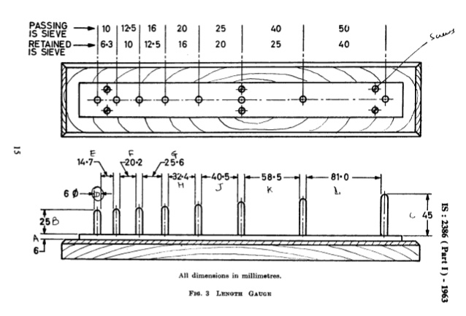

Fig 2. LENGTH GAUGE

**CALCULATION**

Elongation index = x/w * 100 %

Where, *x* is the weight of materials retained on specified gauges

W is the total weights of aggregate passing and retained on the specified sieves.

## REPORTING OF RESULTS

The elongation index is the total weight of the material retained on various length gauges, expressed as the percentage of the total weight of the sample gauged.

## RESULT

Elongation index = …………………..