**Engineering Geology & Remote Sensing (CE-405)**

**Civil Engineering**

**EXPERIMENT NO.1**

**Study of physical properties and Identification of minerals**

**Date of conduction:-**

**Date of submission:-**

**Submitted by other members:-**

**1.**

**2.**

**3.**

**4.**

**5.**

**Group no:-**

**Signature**

**Name of faculty in charge: Ms. Vishakha Yadav**

**Name of Technical Assistant: Mr. Sonu Prajapati**

**AIM:**

The aim of this Experiment is to study and identify some important minerals.

**OBJECTIVES**

After completing this Experiment students should be able to:

* Identify the important rock forming minerals.
* Recognize the minerals of rocks

**Apparatus**: Unglazed porcelain plate (known as a streak plate), hardness scale

**Theory:** Mineral are defined as naturally occurring, inorganic, solids with a definite chemicalcomposition and a regular, internal crystalline structure. Different chemical composition results in different minerals. Mineral are the building blocks of rocks.

**Mineral Physical Property chart**

|  |  |  |
| --- | --- | --- |
| **Physical** **Property** | **Definition** | **Testing Method** |
| Cleavage | Breakage of a mineral  along planes of weakness  in the crystal structure | Examine the mineral for area where the mineral is broken.  Look for area where the light reflects from planar surfaces.  This can be easily confused with a crystal face and is the most  difficult properties for student to master |
| Colour | Visible light spectrum  radiation reflected from a  Mineral. | look at the sample and determine its colour white, green, black,  clear etc. |
| crystal  forms | Geometric shape of a  crystal or mineral | examine and describe the geometric shape of the mineral,  Cubic, hexagonal, etc. Not commonly seen in most lab  samples |
| Fractures | Breakage of a mineral, not  along planes of weakness  in the crystal structure | Examine the mineral for area where the mineral is broken.  Describe the breakage as either irregular or conchoidal (has  the appearance of broken glass) |
| Hardness | Resistance to scratching or  Abrasion | Use mineral of know hardness from the Mohs hardness Kits.  Scratch the unknown mineral with a know hardness to  Determine which is harder. Continue doing this with harder or  Softer minerals from the kit until the hardness is determined. |
| Luster | Character of the light  reflected by a mineral | Look at the samples to determine if the mineral is metallic in  Appearance or non metallic. Vitreous, like glass and earthy  (like dirt, or other Powderly material) |
| Magnetism | Electromagnetic force  generated by an object or  Electric field. | Use of magnet to determined in an introductory lab. |
| Specific Gravity | mineral to the mass of an  equal volume of water | Generally not determined in an introductory lab. |
| Streak | Colour of the mineral when  it is powdered | Grind a small amount of a mineral into a powder on a  Porcelain streak plate and determine the colour of the powder. |

|  |  |  |  |  |  |  |  |  |
| --- | --- | --- | --- | --- | --- | --- | --- | --- |
|  |  |  |  |  | |  |  |  |
|  |  |  |  | **Table -2 Mohr’s scale of Hardness** | | |  |  |
|  |  |  |  | **Hardness** |  | **Mineral** |  |  |
|  |  |  |  | 1 |  | Talc |  |  |
|  |  |  | 2 | |  | Gypsum |  |  |
|  |  |  | 3 | |  | Calcite |  |  |
|  |  |  |  | 4 |  | Fluorite |  |  |
|  |  |  | 5 | |  | Apatite |  |  |
|  |  |  | 6 | |  | Orthoclase |  |  |
|  |  |  |  | 7 |  | Quartz |  |  |
|  |  |  | 8 | |  | Topaz |  |  |
|  |  |  | 9 | |  | Corundum |  |  |
|  |  |  |  | 10 |  | Diamond |  |  |
|  |  |  | | | | | |  |
|  |  | **Table - 3) Specific Gravity of the Impotent Minerals** | | | | | |  |
|  |  | **Mineral** | | |  | **Specific Gravity** | |  |
|  |  | Graphite | | |  | 2.23 |  |  |
|  |  | Quartz | | |  | 2.65 |  |  |
|  |  | Feldspars | | |  | 2.6- 2.75 |  |  |
|  |  | Fluorite | | |  | 3.18 |  |  |
|  |  | Topaz | | |  | 3.53 |  |  |
|  |  | Corundum | | |  | 4.02 |  |  |
|  |  | Barite | | |  | 4.45 |  |  |
|  |  | Pyrite | | |  | 5.02 |  |  |
|  |  | Galena | | |  | 7.5 |  |  |
|  |  | Cinnabar | | |  | 8.1 |  |  |
|  |  | Copper | | |  | 8.9 |  |  |
|  |  | Silver | | |  | 10.5 |  |  |

**PRECAUTIONS:**

1. Handle carefully the soft and flaky minerals.
2. After using the minerals from hardness box put them in proper space assigned for the particular mineral of the hardness scale.

**IDENTIFICATION OF MINERAL**

1. FELDSPAR

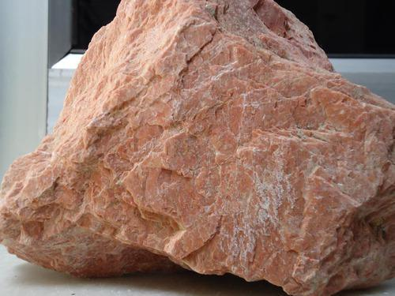

1. Form: Tabular

1. Colour: Pale Pink

3. Streak: White

1. Luster : Vitreous

5. Fracture: Uneven

6. Cleavage: Absent

1. Transparency: Opaque
2. Hardness : 6-7
3. Specific Gravity: Medium
4. Uses : Tiles
5. Name of the Specimen : Feldspar

12. Chemical Composition: KAISi3

1. QUARTZ

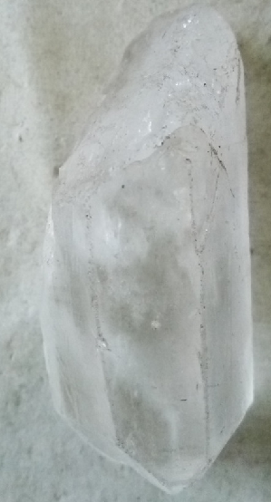

1. FORM : Crystalline
2. Colour : Colourless
3. Streak: Colourless
4. Luster : Vitreous
5. Fracture : Uneven
6. Cleavage : Absent
7. Transparency : Transparent
8. Hardness : 7
9. Specific Gravity: High
10. Name of the Specimen : Quartz
11. Uses : Used as gemstone and in watch industries etc
12. Chemical Composition : SiO2
13. Gypsum

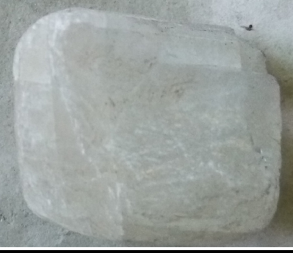

1. Form : Crystalline
2. Colour : White
3. Streak: White
4. Luster : Sub-Vitreous
5. Fracture : Even
6. Cleavage : 2 sets
7. Transparency : Opaque
8. Hardness : 2
9. Specific Gravity: Medium
10. Name of the Specimen : Gypsum
11. Uses : Used as Fertilizer, manufacturing of cement and plaster of Paris
12. Chemical Composition : SiO2

**Engineering Geology & Remote Sensing (CE-405)**

**Civil Engineering**

**EXPERIMENT NO.2**

**Study and Identification of Rocks**

**Date of conduction:-**

**Date of submission:-**

**Submitted by other members:-**

**1.**

**2.**

**3.**

**4.**

**5.**

**Group no:-**

**Signature**

**Name of faculty in charge: Ms. Vishakha Yadav**

**Name of Technical Assistant: Mr. Sonu Prajapti**

**AIM:** To study and identify the rock based on its physical properties.

**Theory:**

Mineral is a naturally occurring inorganic substance having definite chemical composition and with definite internal structure. The branch of geology which deals with the various aspects of minerals such as their individual properties, their mode of formation and mode of occurrence is called as mineralogy. A rock is defined as an aggregate of minerals and the study on rock is called Petrology. Based on their origin, geologically rocks are classified into igneous rocks, Sedimentary rocks and metamorphic rocks.

**Igneous rocks**:

They are derived from solidification of molten material ‘magma’ or ‘lava’. They subjected to different rate of crystallization. Thus, they exhibit different crystalline textures and structures. They are often connected with the interior of the earth’s crust. They are massive in form and free from fossil remains of ancient animals and plants. Ex: Granite from Magma, Basalt from Lava. These rocks are the fore most rocks to be formed on the earth’s crust. So they are known as ‘primary Rocks’. These rocks are characterized by vesicular structure, amygdaloidal structure and Aphanitic structure if they are volcanic. If they are Hypabyssal or plutonic, they are dense, compact and exhibit interlocking texture.

**Sedimentary rocks**:

These rocks are formed by the weathered, transported and deposited on the oceanic floor in the form of layers. They are also known as ‘Layered Rocks’. They are formed under water, they possess evidences of sedimentation viz, stratification, ripple marks, current bedding, graded bedding, mud/sun cracks, rain prints. Fossils etc., Example conglomerate, sand stone, limestone etc.

**Metamorphic rocks**:

These are derived from the pre-existing rocks due to intense temperature, pressure or both. These phenomena known as thermal metamorphism, dynamic metamorphism and dynamo thermal metamorphism respectively. The rocks subjected to metamorphism, lose their original features and new structures are introduced. Example igneous rock Granite is metamorphosed to form Gneiss, sedimentary rock Limestone is metamorphosed to form Marble.

Some of the index properties of rocks are

1. Grain Size
2. Texture / Structure
3. Mineral Composition
4. Cementing Materials
5. Specific Gravity

1. **Colour**: The colour of rocks depends upon their constituent minerals or cementing material.

2. **Texture**: It is the mutual arrangement of component mineral grains size, shape. The texture will be different for igneous, metamorphic and sedimentary rocks.

|  |  |  |
| --- | --- | --- |
| **Texture of Igneous Rocks** | | |
| **Texture** | **Description** | **Example** |
| Equigranular | It consists of almost equidimensional mineral grains | Granite, Gabbro |
| Porphyritic | It consist of few large, well developed mineral grains | Granite porphery |
| Glassy texture | It consists of amorphous surface with rich in silica (SiO2 ) and rapid solidification of lava/magma in volcanic igneous rocks | Rhyolite, Obsidian |
| Vesicular/ Amygdaloidal texture | It consist of pores or vesicles due to release of gaseous substances |  |

|  |  |  |
| --- | --- | --- |
| **Texture of Sedimentary Rocks** | | |
| Massive | Amorphous or very fine –grained and breaks with concentric curves | limestone |
| Fossiliferous | It consists of fossil remains buried, cemented together | Limestone |
| Concretionary | Hard and Soft clay with iron oxide or aluminium oxide | Laterite |

|  |  |  |
| --- | --- | --- |
| **Texture of Metamorphic Rocks** | | |
| Granulose | It consists of interlocking of shapeless grains or crystalline minerals | Quartzite, Marble |
| Schistose | It consists of flaky, foliated grains or layers twisted or curved |  |
| Gneissose | It consists of alternate bands of light coloured and dark coloured mineral | Gneiss, Augen gneiss |

3. **Grain size**:

Fine: Grain diameter 1 mm or less

Medium: Grain diameter 1 mm to 5 mm

Coarse: Grain diameter 5 mm and above

4. **Mineral Composition**:

The combination and proportion of the mineral component in Rock, Mineral

Compositions can be divided in two types:

1. Essential minerals: These are essential for description, identification and classification, of Rocks. Ex: Quartz, Feldspar, Mica. Augite, Calcite, Talc, Chlorite.
2. Accessory minerals: These may be present/obsent. Ex: Mica, Magnite, Iron pyrite, Garnet.

**5.** **Cementing Material: (Exclusively for Sedimentary Rocks)**

Natural binding material deposited in between component sedimentary pebbles,

Fragments, grains and/or fossil remains.

|  |  |
| --- | --- |
| Calcareous | It imparts white colour and pale colour to sand stones and can be known by acid test |
| Feriginous | Imparts shades of brown, red, or yellow colour to sand stone |
| Argillaceous | It provides only weak cohesion for sand particles, which fall of rubbing the sand stone |
| Siliceous | Resembles calcareous cementing material but provides competence and durability to sand stone |
| Glauconitic | It provides green colour to sand stone |

**Identification of rock based on physical properties**

**Group:**

**Colour:**

**Grain Size:**

**Texture and Structure:**

**Essential Minerals:**

**Accessory:**

**Minerals/Cementing:**

**Materials:**

**Specific Gravity:**

**Mode of Origin:**

**Identify Rock:**