**Basic Civil Engineering and Engineering Mechanics (BT-204)**

**Civil Engineering**

**EXPERIMENT NO.1**

**To perform traverse surveying with prismatic compass, check for local attraction and determine corrected bearings and to balance the traverse by Bowditch’s rule.**

**Date of conduction:-**

**Date of submission:-**

**Submitted by other members:-**

**1.**

**2.**

**3.**

**4.**

**5.**

**Group no:-**

**Signature**

**Aim**- Measurement of direction by Prismatic compass.

**Apparatus** - Prismatic compass, tape, chain, arrows, pegs, ranging rods.

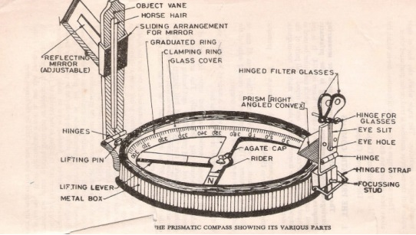

**Figure 1 –Prismatic Compass**

**Theory** – Magnetic compass gives directly the magnetic bearings of the lines. The bearings may either be measured in W.C.B system or in R.B system depending upon the form of the compass used. The bearings so measured are entirely independent of any other measurement.

**Procedure** - Closed traverse is generally run around a structure .It is defined as a series of connected lines whose directions and lengths are determined precisely. Following procedure is adopted to run a closed compass traverse.

1) Let us say we have to run a closed compass traverse ABCDEA.

2) Set the prismatic compass at point A. centre it and level it.

3) Take bearings of traverse lines AB and AE.

4) Shift the compasses to point B centre it and level it. Take the bearings BC & BA.

5) Link-wise complete the traverse as shown in fig (b).

6) Measure the length of traverse line AB, BC, CD, DE, and EA.

7) Record the observation in tabular columns.

8) Care must be taken to see that the stations are not affected by local attractions. If they are affected corrections to local attractions should be applied first and then the traverse should be plotted with corrected bearings.

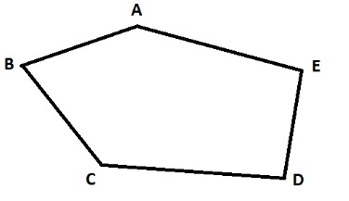

**Fig 2 - Traverse**

**Observation Table -**

|  |  |  |  |
| --- | --- | --- | --- |
| LILINE | F FORE BEARING | BACK BEARING | LENGTH(m) |
| AB |  |  |  |
| B BC |  |  |  |
| C CD |  |  |  |
| D DE |  |  |  |
| E EA |  |  |  |

**Result-** The adjusted traverse with bearings and length is to be shown on a Drawing sheet

**Conclusions-**

**Basic Civil Engineering and Engineering Mechanics (BT-204)**

**Civil Engineering**

**EXPERIMENT NO.2**

**To perform leveling exercise by height of instrument of Rise and fall method.**

**Date of conduction:-**

**Date of submission:-**

**Submitted by other members:-**

**1.**

**2.**

**3.**

**4.**

**5.**

**Group no:-**

**Signature**

**AIM:-** Calculation of R.L. for different points involving 2 instrument stations & reduction byHeight of Instrument & Rise and fall methods.

**INSTRUMENTS:-**

1. Auto Level with a tripod Stand

2. Measuring tape

3. Levelling staff.

**FIGURE:-**

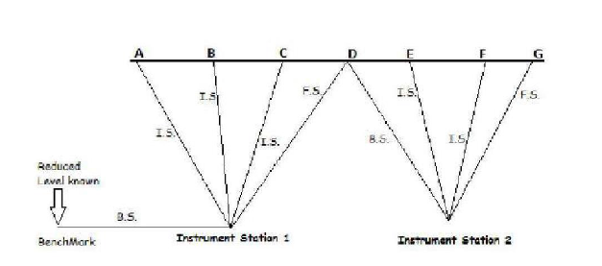

**Fig 1 - Terms related with Levelling**

**Theory:-**

If we know the reduced level of a point in the field, we can use it as a bench mark to determine the R.L. of various points around it. The change of instrument station if needed can be incorporated by sighting a point which was earlier sighted as the Foresight for the previous Station and be noted as the back sight for the new station. This helps us to achieve a reference for the new point of observation. The intermediate sights and foresights is preferably kept equidistant to the back sight on the bench mark. Once the I.S. or F.S. crosses the B.S. distance we change the instrument to another suitable position for further readings. The two methods used to reduce the field observation into useful data are: Height of instrument method and Rise & Fall Method.

**Procedure:-**

1. Setup the auto level instrument at a convenient point- instrument station-1 and carry out the temporary adjustment

2. Take the back Sight on the benchmark whose reduced level is known. If the R.L. is unknown assume a suitable value. Assumption leads to a relative study of elevation of different points with a particular reference. Record this reading under the column B.S. of the field book.

3. Take the staff to the first point A. Record the reading under the I.S. column.

4. Take the staff to the point B. Sight the staff through the telescope and record the reading again under I.S. The same method is repeated for the staff placed at point C

5. Place the staff at point D and sight through the telescope. The observed reading is noted under the F.S. Column.

6. Keep the staff at the same point and shift the instrument to the new location – Instrument Station 2

7. Carry out the temporary adjustments and sight the staffs which is still held vertical at point D. This can be noted as the B.S. for the new position of instrument.

8. Keep sighting the further points E, F, G and record the value on staff under I.S.

9. Finally G is sighted through the telescope and recorded under F.S. for the Second Instrument station.

Note: After the field work is over the recorded details can be used to determine the R.L. of the points A, B, C, D, E, F, G by either Height of Instrument method or Rise and fall method.

**Observation Tables:-**

Table for Height Of Instrument Method.

|  |  |  |  |  |  |  |
| --- | --- | --- | --- | --- | --- | --- |
| Station | B.S. | I.S. | F.S. | Height of Collimation | Reduced Level | Remark |
|  |  |  |  |  |  |  |
| A |  |  |  |  |  |  |
| B |  |  |  |  |  |  |
| C |  |  |  |  |  |  |
|  |  |  |  |  |  |  |

H.I. = B.S. + R.L. of Bench Mark

R.L. of A = H.I. - I.S.

R.L. of B = H.I. - I.S…. And so on

Table for RISE & FALL method

|  |  |  |  |  |  |  |
| --- | --- | --- | --- | --- | --- | --- |
| Station. | READINGS | | | RISE | FALL | R.L. |
| B.S | I.S | F.S |
|  |  |  |  |  |  |  |
|  |  |  |  |  |  |  |
|  |  |  |  |  |  |  |
|  |  |  |  |  |  |  |
|  |  |  |  |  |  |  |
|  |  |  |  |  |  |  |
|  |  |  |  |  |  |  |

B.S- I.S. = +ve -

→

Rise or –ve

→

Fall

R.L. of a point = Previous R.L. + Rise or – fall

**Check:**

Σ B.S – Σ F.S = Σ Rise – Σ fall = Last R.L. – First R.L

**Calculations:-**

**Result:-**

**Conclusion:-**

**Basic Civil Engineering and Engineering Mechanics (BT-204)**

**Civil Engineering**

**EXPERIMENT NO.3(a)**

**To measure horizontal and in the field by using Theodolite.**

**Date of conduction:-**

**Date of submission:-**

**Submitted by other members:-**

**1.**

**2.**

**3.**

**4.**

**5.**

**Group no:-**

**Signature**

**Aim**:- Measurement of horizontal angles theodolite by method of repetition

**Apparatus**: - Theodolite, Ranging rod, pegs etc.

**Figure:-**

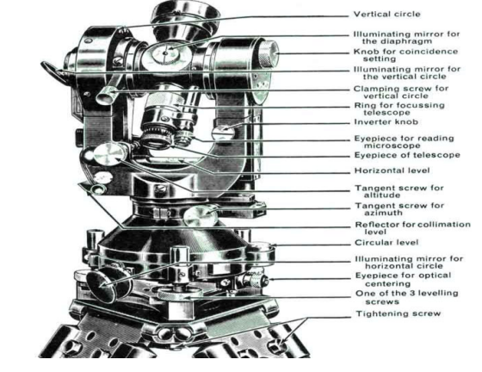

**Fig 1 - Transit Theodolite**

**Theory:-** Theodolite: The theodolite is the most intricate and accurate instrument used for measurement of horizontal and vertical angles. It consists of telescope by means of which distant objects can be sighted. The telescope has two distinct motions on in the horizontal plane and the other in the vertical plane. The former being measured on a graduated Horizontal vertical circle of two verniear. Theodolite are primarily classified as Transit and Non-transit theodolite A theodolite is called transit theodolite when its telescope can be resolved through a complete revolution about its horizontal axis. In a vertical plane, the transit type is largely used. Various parts of transit theodolite

1) Telescope: it is an integral part and is mounted on the spindle known as horizontal axis or turn on axis. Telescope is either internal or external focusing type.

2) The levelling head: It may consists of circular plates called as upper and lower Parallel plates. The lower parallel plate has a central aperture through which a plumb bob may be suspended. The upper parallel plate or tribranch is supported by means of four or three levelling screws by which the instrument may be levelled.

3) To lower plate or screw plate: It carries horizontal circle at its levelled screw. It carries a lower clamp screw and tangent screw with the help of which it can be fixed accurately in any desired position.

4) The upper plate or vernier plate: - it is attached to inner axis and carries two vernier and at two extremities diametrically opposite.

5) Compass: the compass box may be either of circular form or of a rough type. The former is mounted on the vernier plate between the standards while the latter is attached to the underside of the scale or lower plate or screwed to one of the standards. Modern theodolite is fitted with a compass of the tubular type and it is screwed to one of the standards.

6) Vertical circle: the vertical circle is rigidly attached to the telescope and moves with it. It is silvered and it is usually divided into four quadrants. The telescope in front of the vertical axis. It carries two vernier of the extremities of its horizontal arms or limbs called the index arm. The vertical leg called the clip or clipping screws at its lower extremity. The index arm and the clipping arm are together known as T-frame.

7) Plumb bob: To centre the instrument exactly over a station mark, a plumb bob is suspended from the hook fitted to the bottom of the central vertical axis. Repetition method of measuring Horizontal angles when it is required to measure horizontal angles with great accuracy as in the case of traverse, the method of repetition may be adopted. In this method the same angle is added several times by keeping the vernier to remain clamped each time at the end of each measurement instead of setting it back to zero when sighting at the previous station. The corrected horizontal angle is then obtained by dividing the final reading by the number of repetitions. Usually six reading, three with face left and three with face right, are taken The average horizontal angle is then calculated.

**Procedure:-**

1) Let LOM is the horizontal angle to be measured as shown in fig. O is the station point fixed on the ground by a peg. Set up the theodolite over the peg ‘o’ and level it accurately.

2) Set the horizontal graduated circle vernier A to read zero or 360° by upper clamp screw and slow motion screw. Clamp the telescope to bisect the bottom shoe of the flag fixed at point ‘L’ and tighten the lower clamp. Exactly intersect the centre of the theodolite should be left and the telescope in normal position.

3) Check the reading of the vernier A to see that no slip has occurred .Also see that the plate levels are in the centre of their run. Read the vernier B also.

4) Release the upper clamp screw and turn the theodolite clockwise. Biset the flag bottom shoe fixed at point M by a telescope. Tighten the upper clamp screw and bisect the shoe exactly by means of upper slow motion screw.

5) Note the reading on both the vernier to get the approximate value of the angle LOM.

6) Release the lower clamp screw and rotate the theodolite anticlockwise ai azimuth. Bisect again the bottom shoe of the flag at ‘L’ and tighten the lower clamp screw. By means of slow motion screw bisect exactly the centre of the shoe.

7) Release now the upper clamp screw and rotate the theodolite clockwise. Bisect the bottom shoe of the flag fixed at M and tighten the upper clamp screw. By means of slow motion screw bisect exactly the centre of the shoe. The vernier readings will BW now twice the of the angles.

8) Repeat the process until the angle is repeated the required number of times (usually 3). Add 360° for every complete revaluation to the final reading and divided the total angle by number of repetitions to get the value of angle LOM.

9) Change the face of the theodolite the telescope will now be inverted. Repeat the whole process exactly in the above manner and obtain value of angle LOM.

10) The average horizontal angle is then obtained by taking the average of the two angles obtained with face left and face right.

11) Usually three repetitions face left and three with face right should be taken and the mean angle should be calculated.

**Observation Table-**

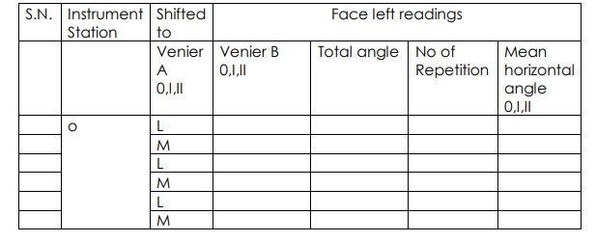

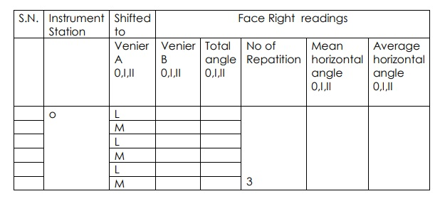

**Calculations:-**

**Result**:- Average horizontal angle is found to be ________

**Conclusion:-**

**Basic Civil Engineering and Engineering Mechanics (BT-204)**

**Civil Engineering**

**EXPERIMENT NO.3(b)**

**To measure vertical angles in the field by using Theodolite.**

**Date of conduction:-**

**Date of submission:-**

**Submitted by other members:-**

**1.**

**2.**

**3.**

**4.**

**5.**

**Group no:-**

**Signature**

**Aim:-** Measurement of vertical Angles with Theodolite

**Apparatus:-** Theodolite, three ranging rods,



**Fig 1- Transit Theodolite**

**Theory**: -

1) Theodolite is an instrument designed for the measurement of horizontal and vertical angle. It is most precise method it is also used for lying of horizontal angles locating points on line prolonging the survey line establishing the gradient, determination of difference in the elevation setting out curve. Theodolite are of two types’ transit and non transit. Transit theodolite is commonly used now a day’s in transit theodolite telescope can be revolved a complete revolution about its horizontal axis in a vertical plane. A transit theodolite consists of essential part. The head comprises of two parts

a) A levelling foot screws for levelling the instrument i.e. for marking vertical axis truly vertical.

b) A movable head or centring arrangement for centring the vertical axis accurately over a station point.

2) A lower level circular horizontal metal plate: It carries a circular graduated arc. The lower plate is attached to a vertical metal spindle (outer axis) which works in vertical bearing and a form a part of levelling head. It may be graduated in degree and half degree or a degree 1/3 of degrees .the upper plate carries an index and vernier or micrometer towards fine reading on gradated horizontal circle .the upper plate carries standard use of for supporting the telescope and the spirit level used for levelling the instrument.

3) A telescope: The telescope is pivoted between the standard at right angles to the horizontal axis . It can be rotated about its horizontal axis in a vertical plane. The telescope is provided with the focusing screw, Clamping screw and tangent screw.

4) A circular graduated are carried on vertical circle: It is attached to the horizontal axis of the telescope, it is usually divided into 4 quadrants, but in some instruments it is graduated continuously from 0-3600.the graduation in each quadrant are numbered from 0-900 in opposite direction. The subdivisions of vertical circle are similar to those of vertical circle.

**Measurement Of Vertical Angle:-** A vertical angle is the angle between the inclined line of sight to an object and the horizontal. It may be an angle of elevation or on angle of depression according as the instrument. To measure angle of elevation or depression LOM shown in fig. proceed as follows:

1) Set up the theodolite at station point O and level it accurately with reference to the altitude level.

2) Set vertical verniers C and D exactly to zero by using the vertical circle clamp and tangent screw, while the altitude level should remain in the centre of its run. Also the face of the theodolite should be left.

3) Release the vertical circle clamp screw and rotate the telescope in vertical plane so as to bisect the object M. tighten the vertical circle clamp and exactly bisect the object by slow motion screw.

4) Read both verniers C and D. the mean of the tow readings gives the value of the required angle.

5) Similar observation may be made with other face. The average of the tow values thus obtained gives the value of the required angle which is free from instrumental errors.

6) Similarly the angle of depression can be measured following the above steps.

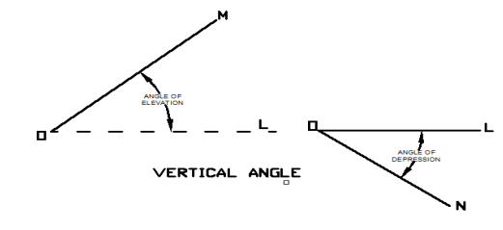

**Fig 2 –Vertical Angle**

To measure the vertical angle between two points L and M Sometimes it is required to measure vertical angle between two points L and M. There can be three possibilities.

(a) One point is above the line of sight and the other is below the line of sight then angle LOM as shown in fig will be equal to

(b) Both the points are above the line of sight. Then the angle LOM (Refer Fig 2)

(c) Both the points are below the line of sight, then the angle LOM (Refer Fig 3)

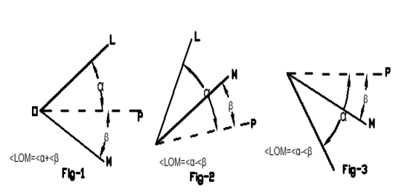

To measure the angle between two points L and M proceed as follows

1) Set the theodolite at station point O and accurately level it.

2) Bisect the flag at L as explained already and take the reading on the verniers C and D. Calculate the mean angle.

3) Bisect the flag at M as before and take the reading on the verniers C and D. Calculate the mean angle between points L and M.

**Observation table:-**

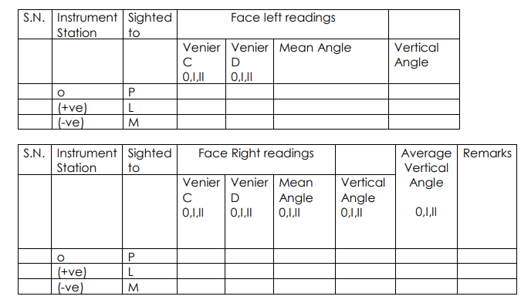

**Calculations:**

**Result-:** The average value of vertical is found to be _________________

**Conclusion:**