**Basic Civil Engineering and Engineering Mechanics (BT-204)**

**Civil Engineering**

**EXPERIMENT NO.4(a)**

To determine Normal Consistency

**Date of conduction:-**

**Date of submission:-**

**Submitted by other members:-**

**1.**

**2.**

**3.**

**4.**

**5.**

**Group no:-**

**Signature**

**Name of faculty in charge:**

**Name of Technical Assistant:**

Aim- To find the percentage of water required to prepare a cement paste of standard consistency.

**Apparatus** -

1. Vicat apparatus
2. Balance
3. Measuring cylinder
4. IS sieve No.9
5. weighing balance
6. trowel

**Theory -**

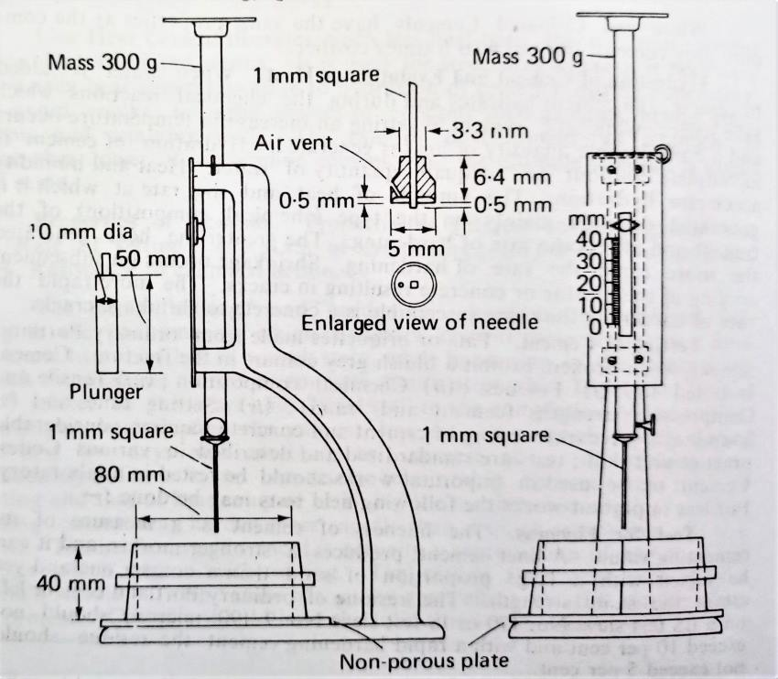

**Theory** –

Consistency of cement is defined as minimum quantity of water added in cement to form uniform paste that provide sufficient viscosity and desirable strength for different type of structural work. Adding less or excess amount of water in cement causes reduction in its strength

**Procedure** –

1. Keep the vicat apparatus on a level base (when using vicat apparatus with dashpot, keep the bearing movable rod to its highest position and pin it.) Unscrew the top of the dashpot. Half fill the dashpot with any suitable oil of viscosity and screw the top. Work the plunger a number of times.
2. Attach the plunger for determining standard consistency to the movable rod. Work the plunger a number of times.
3. Take 400 gm of cement in a pan and a weighed quantity of water in a beaker.
4. Prepare a paste with the water added to cement. Start a stopwatch at the time of adding water to cement.
5. Keep the vicat mould on a non porous plate and fill the cement paste in it.
6. After completely filling the mould, shake it slightly to expel the air. Smooth off the surface of the paste making it level with the top of the moulder. The cement paste thus prepared is the test block.
7. Place the test block resting on the non porous plate under the movable rod, bearing the needle.
8. Lower the plunger gently to touch the surface of the cement paste and quickly release; (when vicat apparatus with dashpot is used, place the mould filled with cement paste and the non absorbent plate on the base plate of the vicat apparatus. Raise the plunger of the dash pot, bring it in contact with the top cap of the movable bearing rod.
9. Remove the pin holding the movable bearing rod to the surface of the cement paste and quickly release by pushing down the plunger to sink in to the paste). This operation shall be done immediately after filling the mould.
10. Prepare trial test specimens with varying percentages of water until plunger penetrates to a point 5 to 7mm from the bottom of the vicat mould, which is read on the scale. Express the water required as percentage by weight of the dry cement.

# Observation Table:

|  |  |  |  |
| --- | --- | --- | --- |
| S.No | Amount of water added | Penetration of the plunger  from the bottom | Remarks |
|  |  |  |  |
|  |  |  |  |
|  |  |  |  |
|  |  |  |  |

Result: The normal/standard consistency of the cement =

**Basic Civil Engineering and Engineering Mechanics (BT-204)**

**Civil Engineering**

**EXPERIMENT NO.4(b)**

To determine Initial and Final Setting time of a cement sample

**Date of conduction:-**

**Date of submission:-**

**Submitted by other members:-**

**1.**

**2.**

**3.**

**4.**

**5.**

**Group no:-**

**Signature**

**Name of faculty in charge:**

**Name of Technical Assistant:**

Objective: To find out the initial and final setting of the given sample of cement.

Apparatus required: Vicats apparatus with mould, IS Sieve No.9, Initial and final time needles, Measuring jar, Weighing balance, Stop watch.

Theory: The setting time of cement divided as the initial setting time and final setting. Initial setting time is the time from the addition of water to the time when the cement paste starts losing its plasticity.

Final setting time is the total time from the addition of water till the cement paste completely loses its plasticity.

# Procedure:

1. Prepare a cement paste by adding water lesser than required for standard consistency.
2. Start the stop watch as soon as the water is added.
3. Fill the vicats mould with the prepared cement paste. The mould should rest on anon- porous plate and the top of the paste must be smoothen off to the level of the top surface of the mould.

Initial setting time

1. Place the test block under the rod bearing the needle.
2. Lower the needle gently such that it touches the topmost surface of the cement paste and release it to allow it to penetrate through the paste. Repeat the procedure till the needle doesn’t pierce to a point 5.00mm approx. from the bottom of the mould.
3. Note the time elapsed till now. This gives the initial setting time of the cement.

Final setting time

1. Replace the needle with the final setting one with annular attachment.
2. The movable rod is slowly released. In the initial stage the needle and the collar may pierce through the paste.
3. The time when the needle makes an impression and the attachment fails to do so the stopwatch is paused. This gives the final setting of the cement paste.

# Result:

# Initial setting time=

# Final setting time=

**Basic Civil Engineering and Engineering Mechanics (BT-204)**

**Civil Engineering**

**EXPERIMENT NO.5(a)**

To determine the workability of fresh concrete of given proportions by slump test

**Date of conduction:-**

**Date of submission:-**

**Submitted by other members:-**

**1.**

**2.**

**3.**

**4.**

**5.**

**Group no:-**

**Signature**

**Name of faculty in charge:**

**Name of Technical Assistant:**

Objective: To make quantities asses workability of prepared concrete mix.

**Apparatus required:** Slump cone, Temping rod, Measuring Scale, Prepared concrete mix.

Theory: The slump test indicates the behavior of a compacted concrete cone under the action gravitational forces. The test is carried out with a mould called the slump cone. It must be appreciated that the different concretes of same slump may, indeed, have different workability under the site condition.

# Procedure:

1. Prepare a concrete mix of a specification.
2. The slump cone is placed on a horizontal and non-absorbent surface.
3. Fill the slump cone with the prepared concrete mix in three equal layers, each layers being tamped 25 times with a standard tamping rod.
4. Level the top layer, lift the mould vertically without disturbing the concrete cone.
5. The slump (subsidence of concrete in mm) is observed.

# Observation:

The slump subsidence of the concrete mix( : : ) =

# General:

If the concrete after the test when slump evenly all around is called true slump. In case of a very lean concrete, one-half of the cone may slide down the other which is called a shear slump; or it may collapse in case of very wet concrete.

If the slump value is between 25mm to 75mm, concrete is of medium workability and if slump value 75mm to 125mm the concrete is of high workability. If the slump value is almost zero, the concrete is very stiff and non-workable.

Result: The prepared concrete mix is of Workability.

**Basic Civil Engineering and Engineering Mechanics (BT-204)**

**Civil Engineering**

**EXPERIMENT NO.5(b)**

To determine the workability of fresh concrete of given proportions by compaction factor test

.

**Date of conduction:-**

**Date of submission:-**

**Submitted by other members:-**

**1.**

**2.**

**3.**

**4.**

**5.**

**Group no:-**

**Signature**

**Name of faculty in charge:**

**Name of Technical Assistant:**

**Objective:** To determine the workability of prepared concrete mix by compacting factor apparatus.

Apparatus required: Compacting Factor apparatus, Oil (for lubrication), prepared concrete mix, tamping rod.

Theory: The compacting factor test indicates the workability of a compacted concrete. The test is carried out with a compacting factor apparatus. It is the ratio of the compaction of concrete due to self weight and compaction of same concrete due to compaction done by mechanical way.

# Procedure:

1. Prepare a concrete mix of a specific ratio.
2. Apply oil to the apparatus for its smooth work.
3. Take a weight of empty cylindrical shape equipmentW1.
4. Fill the prepared mix in the upper cone of apparatus.
5. Now, by the use of handle open the door of upper cone and allow the concrete to fall in lower cone due to self weight.
6. Repeat the same and then collect the prepared mix in cylindrical shape equipment due to self weight.
7. Take a weight of filled cylindrical shape equipmentW2.
8. Now, fill the cylindrical equipment with the prepared concrete mix in three equal layers, each layers being tamped 25 times with a standard tamping rods.
9. Level the top layer and then take weight of that cylindrical equipmentW3.

**Calculation:** Weight of empty cylindrical equipment W1

# Observation:

The compaction factor of the concrete mix( : : ) =

General: If the concrete after the test when slump evenly all around is called true slump. In case of a very lean concrete, one-half of the cone may slide down the other which is called a shear slump; or it may collapse in case of very wet concrete.

If the slump value is between 25mm to 75mm, concrete is of medium workability and if slump

value 75mm to 125mm the concrete is of high workability. If the slump value is almost zero, the concrete is very stiff and non-workable.

Result: The prepared concrete mix is of Workability.

**Basic Civil Engineering and Engineering Mechanics (BT-204)**

**Civil Engineering**

**EXPERIMENT NO.6**

**To determine the Compressive Strength of the brick**

**Date of conduction:-**

**Date of submission:-**

**Submitted by other members:-**

**1.**

**2.**

**3.**

**4.**

**5.**

**Group no:-**

**Signature**

**Name of faculty in charge:**

**Name of Technical Assistant:**

Objective: To find the compressive strength of the brick.

**Apparatus required:** Universal testing machine, Brick sample, Cement, Measuring scale.

Theory: The brick ultimately has to bear the compressive load, so it become of prime importance to find out the compressive strength of the same. Compressive strength means the compression load acting on the brick divided by the area of the brick upon which the load acts.

Final setting time is the total time from the addition of water till the cement paste completely loses its plasticity.

# Procedure:

1. Select a brick randomly and immerse it in the water for 24 hours.
2. Wipe the brick properly with dry cloth and fill the frog with 1:1 cement mortar.
3. The bricks are kept under damp jute bags for 24hours thereafter immerse in the water for 3 days
4. Wipe the bricks properly with dry cloth and measure the dimensions of the brick.
5. Place the brick under the compression testing machine with frog face upwards
6. The load is applied axially with the speed of 14N/mm2 until the brick is crushed. Note the load.

# Calculation:

Load at which the brick fails (L) =

Area of the brick directly under the load (A) =

Compressive strength=

Result: The compressive strength of the brick sample is………….

**Basic Civil Engineering and Engineering Mechanics (BT-204)**

**Civil Engineering**

**EXPERIMENT NO.7(a)**

To determine the fineness modulus of the given sample of coarse aggregate

.

**Date of conduction:-**

**Date of submission:-**

**Submitted by other members:-**

**1.**

**2.**

**3.**

**4.**

**5.**

**Group no:-**

**Signature**

**Name of faculty in charge:**

**Name of Technical Assistant:**

Objective: To determine the fineness modulus of the given sample of coarse aggregate by sieve analysis method.

Apparatus required: IS sieve required for sieve analysis as per IS2386-1963, Balance, and sieve shaker.

Theory: The fineness modulus is a numerical index fineness equal to the sum of cumulative percentages of material retained on set of ten sieves divided by 100. The aggregate passing through 4.75mm is called Fine aggregate. The aggregate retained on the 4.75mm sieve is called coarse aggregate. To provide the most economical mix and to get the optimum workability, fineness modulus is an important criteria.

# Procedure:

1. Arrange the sieve in the order such as 80mm sieve is at the top and 150mm at the bottom.
2. Dry the aggregate properly before weighing and sieving.
3. Weigh 2kg of coarse aggregate and place it on the top most sieve.
4. Shake the sieve mechanically or manually. It should be taken care that the shaking should be of varied motion, backwards and forwards, left and right, circular clockwise, circular anticlockwise.
5. This should be continued for 2minutes or more.
6. On completion the material retained on each sieve shall be weighed.

# Observations:

|  |  |  |  |  |  |  |  |
| --- | --- | --- | --- | --- | --- | --- | --- |
| IS sieve | | Weight if coarse  aggregate retained | | Cumulative weight  retained | | Cumulative  percentage retained | |
| 80mm | |  | |  | |  | |
| 40mm | |  | |  | |  | |
| 20mm | |  | |  | |  | |
| 10mm |  | |  | |  | |
| 4.75mm | |  | |  | |  | |

**Result:** The fineness modulus of coarse aggregate…………

**Basic Civil Engineering and Engineering Mechanics (BT-204)**

**Civil Engineering**

**EXPERIMENT NO.7(b)**

To determine the fineness modulus of the given sample of fine aggregate

.

**Date of conduction:-**

**Date of submission:-**

**Submitted by other members:-**

**1.**

**2.**

**3.**

**4.**

**5.**

**Group no:-**

**Signature**

**Name of faculty in charge:**

**Name of Technical Assistant:**

Objective: To determine the fineness modulus of the given sample of fine aggregate by sieve analysis method.

Apparatus required: IS sieve required for sieve analysis as per IS2386-1963, Balance, and sieves shaker.

Theory: The fineness modulus is numerical index fineness equal to the sum of cumulative percentages of material retained on set of ten sieves divided by 100. The aggregate passing through 4.75mm is called Fine aggregate. The aggregate retained on the 4.75mm sieve is called coarse aggregate. To provide the most economical mix and to get the optimum workability, fineness modulus is an important criteria.

# Procedure:

1. Arrange the sieve in the order such as 80mm sieve is at the top and 150mm at the bottom.
2. Dry the aggregate properly before weighing and sieving.
3. Weigh 2kg of fine aggregate and place it on the top most sieve.
4. Shake the sieve mechanically or manually. It should be taken care that the shaking should be of varied motion, backwards and forwards, left and right, circular clockwise, circular anticlockwise.
5. This should be continued for 2minutes or more.
6. On completion the material retained on each sieve shall be weighed.

# Observations:

|  |  |  |  |  |  |  |  |
| --- | --- | --- | --- | --- | --- | --- | --- |
| IS sieve | | Weight if coarse  aggregate retained | | Cumulative weight  retained | | Cumulative  percentage retained | |
|  | |  | |  | |  | |
| 4.75mm | |  | |  | |  | |
| 2.36mm | |  | |  | |  | |
| 1.08mm | |  | |  | |  | |
| 600u |  | |  | |  | |
| 300u | |  | |  | |  | |
| 150u | |  | |  | |  | |
| 90 | |  | |  | |  | |

**Result:** The fineness modulus of coarse aggregate…………