**Advance Surveying Lab (CE-605)**

**Civil Engineering**

**EXPERIMENT NO.1**

**Measurement of Distance by Chaining and Ranging**

**Date of conduction:-**

**Date of submission:-**

**Submitted by other members:-**

**1.**

**2.**

**3.**

**4.**

**5.**

**Group no:-**

**Signature**

**Name of faculty in charge:**

**Name of Technical Assistant:**

**AIM**: Measurement of distance by Ranging and Chaining.

**INSTRUMENTS**:- Chain, Arrows, Tapes, Ranging Rods, Offset Rods, Cross staff or optical square, Plumb bob, wooden mallet, pegs.

**FIGURE:**

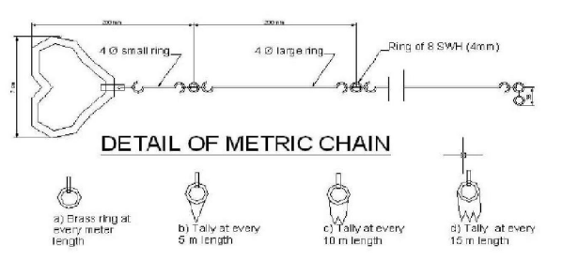

**THEORY:** By the various methods of determining distance the most accurate and common method is the method of measuring distance with a chain or tape is called Chaining. For work of ordinary precision a chain is used. But where great accuracy is required a steel tape is invariably used.

The term chaining was originally applied to measure Distance with a chain. The term chaining is used to denote measuring distance with either chain or tape, In the process of chaining, the survey party consists of a leader (the surveyor at the forward end of the chain) a follower (thesurveyor at the rare end of the chain and an assistant to establish intermediate points). The accuracy to which measurement can be made with chain and tape varies with the methods used and precautions exercised. The precision of chaining. For ordinary work, ranges from 1/1000 to 1/30,000 and precise measurement such as Baseline may be of the order of 1000000. The chain is composed of 100 or150 pieces of galvanized mild steel were 4mm in diameter called links. The end of each link is bent into a loop and connected together by means of three oval rings which afford flexibility to the chain and make it less liable to become kinked. The ends of chain are provided with brass handles for dr agging the chain on the ground, each with a swivel Joints so that the chain can be turned round without twisting. The length of the A link is the distance between the centres of the two consecutive middle rings. The end links include the handles metallic rings indicators of distinctive points of the Chain to facilitate quick reading of fractions of chain in surveying measurements.

RANGING RODS: The ranging rods are used for marking the positions of Stations conspicuously and for ranging the lines. Io order to make these visible at a distance, they are painted alternately black and white, or red and white or red White and black successively. The adjustment of the chain should as far as possible be affected symmetrically on either side of the middle so as that the position of central tag remains unaltered. In measuring the length of survey line also called as chain line. It is necessary that the chain should be laid out on the ground in a straight line between the end stations.

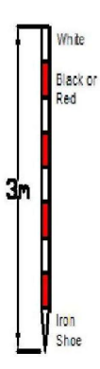

**Fig.2- Raning Rod**

**PROCEDURE:** Two men are required for chaining operation; The chain man at the forward end of chain is called the leader while the other man at the rear end is known as the follower. Duties of leader &follower

Leader:-

1) To put the chain forward

2) To fix arrows at the end of chain

3) To follow the instruction of the followers

**Follower:-**

1) To direct the leader to the line with the ranging rod.

2) To carry the rear end of the chain.

3) To pick up the arrows inserted by the leader.

Chaining

1) The follower holds the zero handle of the chain against the peg &directs the leader to be in line of the ranging rod.

2) The leader usually with to arrows drags the chain alone the line.

3) Using code of signals the follower directs the leader as required to the exactly in the line.

4) The leader then fixes the arrows at the end of chain the process is repeated.

Ranging

1) Place ranging rods or poles vertically behind each point

2) Stand about 2m behind the ranging rod at the beginning of the line.

3) Direct the person to move the rod to right or left until the three ranging rods appear exactly in the straight line.

4) Sight only the lower portion of rod in order to avoid error in non-vertically.

5) After ascertaining that three rods are in a straight line, ask the person to fix up the rod.

**RESULT:** By Chaining and ranging the total distance is found to be______________ PRECAUTIONS: Write down the precautions you have taken during this experiment in field.

**Advance Surveying Lab (CE-605)**

**Civil Engineering**

**EXPERIMENT NO.2**

**Locating various object by chain & cross staff survey**

**Date of conduction:-**

**Date of submission:-**

**Submitted by other members:-**

**1.**

**2.**

**3.**

**4.**

**5.**

**Group no:-**

**Signature**

**Name of faculty in charge:**

**Name of Technical Assistant:**

**AIM:-** Locating various object by chain & cross staff survey

**INSTRUMENTS**:- Chain, Ranging rod, Arrows, Cross-staff, Metallic Survey (Tape)

**FIGURE:-**

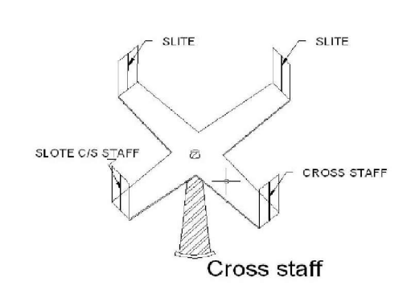

Fig.1- Cross staff

**THEORY:-** Cross-Staff is the simplest instrument used for setting out perpendicular i.e. taking offsets from a chain line. it is easier and quicker method ,but not very accurate . If great accuracy is desired, the work should be carried out by the theodolite. Open cross staff:- The simplest Type consists two parts 1) the head 2) the leg .the head is made of wooden block octagonal or round in shape about 15cm side or diameter an 4cm deep . On it are scribed two lines at right angles to another .At the end of these 4cm deep. on it are scribed two lines at right angles to another .At the end of these lines of sight which are at right angles toone another .The head is fixed on a wooden staff or pole about 3cm in diameter and 1.2 to 1.5m length .The pole is provided conical metal shoe so that it can be driven into the ground

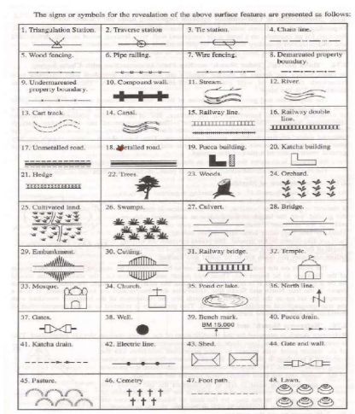

**PROCEDURE:-**

1. To find the foot of the perpendicular from the object the cross staff is held approximately in position and one pair of slits is directed in the direction of the ranging rod fixed at the forward and the chain line . The observer then looks through the other pair of slits and sees whether the particular object is bisected or not. if not the cross staff is moved to and from till the necessary bisection is obtained. Before noting down the chain age of the foot of the perpendicular care must be taken to see that one pair of slit is the direction of chain or not. While shifting the position of the cross-staff it may get twisted and hence precaution is necessary.

2. To set a perpendicular to the chain line at a given point one pair of slits is oriented in the direction of chain line by looking at the ranging rod fixed at the forward and by looking through the other pair of slits ranging rod is fixed in the direction of the line of sight provided by this pair.

**RESULT:-** Various perpendicular to the chain line object are created using cross-staff survey.

**Advance Surveying Lab (CE-605)**

**Civil Engineering**

**EXPERIMENT NO.3**

**Measurement of bearings of sides of traverse with prismatic compass and computation of correct included angle**

**Date of conduction:-**

**Date of submission:-**

**Submitted by other members:-**

**1.**

**2.**

**3.**

**4.**

**5.**

**Group no:-**

**Signature**

**Name of faculty in charge:**

**Name of Technical Assistant:**

**AIM:-** Measurement of bearings of sides of traverse with prismatic compass and computation of correct included angle.

**INSTRUMENTS**:- Prismatic compass, ranging rod, chain, tape, peg Tripod stand , small pieces of stones.

**FIGURE:-**

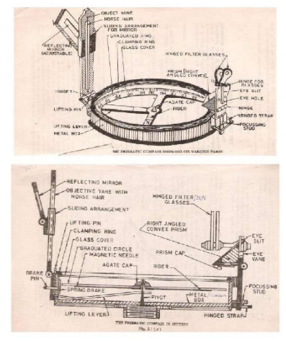

Fig.1- Prismatic compass

**THEORY:-** The important parts of compass are:-

1) A box with graduated circle.

2) A magnetic needle

3) A line of sight When the line of sight is pointed to point, the magnetic needle of compass points towards north (Magnetic meridian).

The angle which this line of sight makes with the magnetic meridian is read on graduated circle. It is known as magnetic bearing of the line.

**There are two types of compasses: -**

**1) Prismatic compass**

**2) Surveyor’s compass**.

**Prismatic Compass**: - prismatic compass is very valuable instrument. It is usually used for rough survey for measuring bearing and survey lines. The least count of prismatic compass is 30 min. It consists of circular box of 10cm-12 cm dia. of non magnetic material. pivot is fixed at the centre of box and is made up of hard steel with a Sharp pivot. Graduated aluminium is attached to the needle.

It is graduated in clockwise direction from 0o to 360o. The figures are written in inverted. Zero is written at south end and 180 at north end and 270 at the east. Diametrically opposite are fixed to the box. The sighting vane consists of a hinged metal frame in the centre of which is stretched a vertical Horse hair fine silk thread of which is stretched a vertical hair. it presses against a lifting pin which lift the needle of the pivot and holds it against the glass lid. Thus preventing the wear of the pivot point to damp the oscillations of the needle when about to take reading and to bring to rest quickly, a light spring is brought lifted inside the box. The face of the prism can be folded out the edge of the box when North end is used Sometime the sighting vanes is provided with a hinge mirror Which can be placed upward or downwards on the frame and can be also Sided along it is required. The mirror can be made inclined at any angle so that Objects which are too high or too low can be sighted directly by reflecting. BEARING OF LINES: A bearing of a line is a horizontal angle made by the survey line with some reference direction or meridian. Meridian may be

1) A true meridian

2) A magnetic meridian

3) An arbitrary or assumed meridian True meridian:

The true geographical meridian passing through a point is a line of intersection of earth’s surface by a plane containing north south pole and given point. They are not parallel to each other at different places. Magnetic meridian:-the direction indicates by a free suspended and a properly balanced magnetic needle Free from all other attractive forces. The direction of magnetic meridian can be established with the help of Magnetic compass Arbitrary meridian: Any direction is assumed to be the Reference meridian to Carry out small survey. Whole Circle Bearing: In whole circle bearing system, the bearing of a line is always measured clockwise from the north point of the reference meridian towards the line right round the circle. The angle thus measured between the reference meridian and the line is called Whole circle bearing of the line. Angles measured will have value between 0 to 360 degrees.

Conversion of W.C.B. in R.B

|  |  |  |  |
| --- | --- | --- | --- |
| Case | WCB between | R.B. | QUADRANT |
| 1 | 0 TO 90 | WCB | N-E |
| 2 | 90 TO180 | 180-WCB | S-E |
| 3 | 180 TO270 | WCB-180 | S-W |
| 4 | 270 TO 360 | 360-WCB | N-W |

Reduced bearing (R.B): In this system of bearing of a line is measured clockwise or anticlockwise from north or south direction whichever is nearer to the line towards east or west. The concept of reduced bearing facilitates computations in traverse surveying.

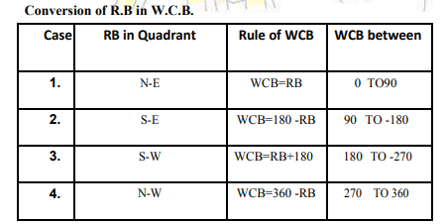

Adjustment of the Prismatic Compass: The compass may be held in hand but for better results it should be fitted at the top of tripod having ball and socket arrangement. The adjustment of a compass is done in the following three steps.

**1) Centering: -** The compass fitted over the tripod Is lifted bodily and placed approximately on the station peg by spreading the leg of a tripod equally, The centre of the compass is checked by dropping a small piece of stone from the centre of the bottom of the compass so that it falls on the top of the station peg. A plumb bob may be used to judge the cantering either BT attaching it with a hook providing at the bottom or otherwise by holding it by hand.

**2) Levelling:-**After the compass is centred, it is levelled by means of ball and socket arrangement so that the graduated circle may swing freely. It can be checked roughly by placing a round pencil on the top of the compass, when the pencil does not move, that is roughly the horizontal position.

**3) Focusing the prism: -** The prism attached is moved up and down so that graduation on the graduated circle should become sharp and clear.

**LOCAL ATTRACTION:-**

Sometimes .the magnetic needle does not point towards magnetic North or South. The reason being that the needle may be under the influence of external attractive forces which are produced due to magnetic substances thus the deflection of the needle from its original position, due to the presence of some magnetic substances is known as local attraction. To detect local attraction at a particular place, fore and back bearing of each line are taken. Then difference comes out to be 180° there is no local attraction at either station. On the other hand of the difference is other than 180°, the bearing may be rechecked to find out the discrepancy may not be due to the presence of iron substance near to the compass. If the difference still remains the local attraction exists at on or both the stations.

**Elimination of Local attraction:-**

**1st method: -** In this method, the bearing of the other lines are corrected and calculated on the basis of the a line which has the difference between its fore bearing and back bearing equal to 180°. The magnetic of the error is formed due to local attraction by drawing a sketch of observed and correct bearing of the line at each station. The error will be negative when the observed bearing is less than the corrected one and the correction will be positive and vice versa. If however, there is no such line in which the difference of fore bearing and back bearing is equal to 180°, the correction should be made from the mean value of the bearing of that line in which the difference between the fore and the back bearing is the least. If the bearings are observed in Quadrant system, the correction should be applied in proper direction by drawing a neat sketch roughly.

**2nd Method: -** This method is more general as the bearing at a station locally affected may be incorrect but include angles calculated from these bearing will be correct since the amount of the error will be the same for all the bearing observed from that station. Thus starting from the unaffected line and using these included angles the correct bearing of all other lines can be calculated. Note: - The sum of the internal included angles must be equal to (2n-4) right angles where n=number of sides of a closed traverse. PROCEDURE:

1) Four ranging rods are fixed at different points i.e. A, B, C, D, E etc. such that it should be mutually visible and may be measured easily.

2) Measure the distance between them. At point A the prismatic compass is set on the tripod Stand, cantering and levelling is• then properly done. The ranging rod at B is ranged through sighting slits and objective vane attached with• horse hair and reading on prismatic compass is noted down.

3) it is fore bearing of line AB. Then the prismatic compass is fixed at B and ranging rod at C. AND A are sighted. And reading is taken as forbearing of BC and back bearing Of AB. 4) Repeat the same procedure at the stations C, D etc

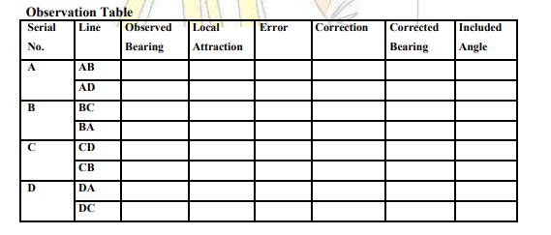

**SAMPLE CALCULATION: -** Error = observed bearing –corrected bearing Check = (2n-4) x 90o RESULT: The prismatic compass is studied and bearing of lines of traverse are Observed, the correction due to local attraction at affected station is done and corrected bearings are written in tabular form

**Advance Surveying Lab (CE-605)**

**Civil Engineering**

**EXPERIMENT NO.4**

**Determination of elevation of various points with dumpy level by collimation plane method and rise & fall method**

**Date of conduction:-**

**Date of submission:-**

**Submitted by other members:-**

**1.**

**2.**

**3.**

**4.**

**5.**

**Group no:-**

**Signature**

**Name of faculty in charge:**

**Name of Technical Assistant:**

**AIM OF THE EXPERIMENT: -**Determination of elevation of various points with dumpy level by collimation plane method and rise & fall method.

**APPARATUS REQUIRED:-** Dumpy level, levelling staff

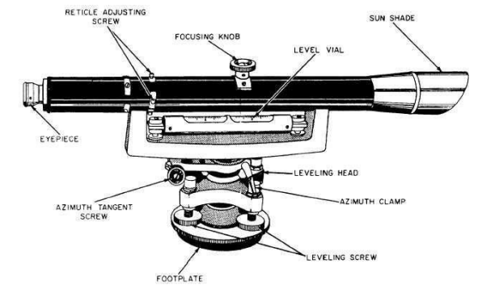

Fig.1-DUMPY LEVEL

**THEORY:**

**Levelling:-** The art of determining and representing the relative height or elevation of different object/points on the surface of earth is called levelling. It deals with measurement in vertical plane.

By levelling operation, the relative position of two points is known whether the points are near or far off. Similarly, the point at different elevation with respect to a given datum can be established by levelling.

**LEVELLING INSTRUMENTS:-** The instrument which are directly used for levelling operation are:- Level, Levelling staff

**Level: -** An instrument which is used for observing staff reading on levelling staff kept over different points after creating a line of sight is called a level.

The difference in elevation between the point then can worked out. A level essentially consists of the following points:

1) Levelling Heads

2) Limb plate

3) Telescope

Telescope consists of two tubes, one slide into the other and fitted with lens and diaphragm having cross hairs. It creates a line of sight by which the reading on the staff is taken.

The essential parts of a telescope are

1) body

2) object glass

3)Eye-piece

4) Diaphragm

5) Ray shade

6) The rack and pinion arrangement

7) Focusing screw

8) Diaphragm screw.

4) Bubble tube

5) Tripod stand

**Dumpy level:-**

The dumpy level is simple, compact and stable instrument. The telescope is rigidly fixed to its supports. Hence it cannot be rotated about its longitudinal axis or cannot be removed from its support. The name dumpy is because of its compact and stable construction. The axis of telescope is perpendicular to the vertical axis of the level. The level tube is permanently placed so that its axis lies in the same vertical plane of the telescope but it is adjustable by means of captain head not at one end. The ray shade is provided to protect the object glass. A clamp and slow motion screw are provided in modern level to control the movement of spindle, about the vertical axis. The telescope has magnifying power of about thirty diameters. The level tube is graduated to 2mm divisions and it has normally a sensitiveness of 20 seconds of are per graduation. The telescope may be internally focusing or external focusing type.

Adjustment of the level the level needs two type of adjustment

1) Temporary adjustment and

2) Permanent adjustment

Temporary adjustments of dumpy level these adjustments are performed at each set-up the level before taking any observation.

(**A)Setting up the level:-** This includes

**1) Fixing the instrument in the tripod:-** The tripod legs are well spread on the ground with tripod head nearly level and at convenient height. Fix up the level on the tripod.

**2) Leg adjustment:-** Bring all the foot screws of the level in the centre of their run .Fix any two legs firmly into the ground by pressing them with hand and move the third leg to leg to right or left until the main bubble is roughly in the centre. Finally the legs is fixed after cantering approximately both bubbles. This operation will save the time required for levelling.

**(B)Levelling: -** Levelling is done with the help of foot screws and bubbles. The purpose of levelling is to make the vertical axis truly vertical. The method of levelling the instrument depends upon whether there are three foot screws or four foot screws. In all modern instruments three foot screws are provided and this method only is described.

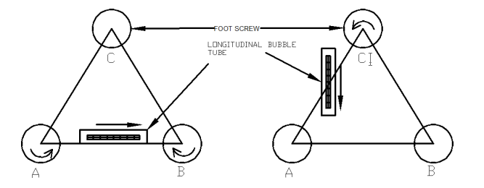

1) Place the telescope parallel to pair of foot screws.

2) Hold these two foot screw between the thumb and first finger of each hand and turn them uniformly so that the thumbs move either toward each other until the bubble is in centre.

3) turn the telescope through 90°so that it lies over the third foot screw.

4) Turn this foot screw only until the bubble is centred.

5) Bring the tescope back to its original position without reversing the eye piece and object glass ends. 6) Again bring the bubble to the centre of its run and repeat these operation until the bubble remains in the centre of its run in both position which are at right angle to each other.

7) Now rotate the instrument through 180°, the bubble should remain in centre provided the instrument is in adjustment: if not ,it needs permanent adjustment.

**c) Focusing the eye piece:-** To focus the eye piece, hold a white paper in front of the object glass ,and move the eye piece in or out till the cross hairs are distinctly seen. Care should be taken that the eye piece is not wholly taken out ,some times graduation are provided at the eye piece and that one can always remember the particular graduation position to suit his eyes, This will save much time of focussing theeye piece.

**(d) Focusing the object glass:** - Direct the telescope to the levelling staff and on looking through the telescope, turn the focusing screw until the image appears clears and sharp. The image is thus formed inside the plane of cross hairs, Parallax, if any is removed by exact focusing. It may be noted that parallax is completely eliminated when there is no change in staff reading after moving the eye up and down.

Reduced Levels

The system of working out the reduced level of the points from staff reading taken in the field is called as reduced level (R.L) of points is the elevation of the point with reference to the same datum.

There are two systems of reduced levels

1) The plane of collimation system (H.I. method)

2) The Rise and fall system

1) The plane of collimation system (H.I. method) in this system, the R.L. of plane of collimation (H.I) is found out for every set-up of the level and then the reduced levels of the points are worked out with the respective plane of collimation as described below.

1) Determine the R.L. of plane of collimation for the first set up of the level by adding B.S. to the R.L. of B.M. i.e. (R.L of plane of collimation= R.L. ofB.M.+B.S.)

2) Obtained the R.L. of the intermediate points and first change point by subtracting the staff readings (I.S. and F.S. from the R.L. of plane of collimation (H.I). (R.L. of a point=R.L of plane of collimation H.I.-I.S or F.S)

3) When the instrument is shifted and set up at new position a new plane of collimation is determined by addition of B.S. to the R.Lof change point. Thus the levels from two set-ups of the instruments can be correlated by means of B.S. and F.S. taken on C.P.

4) Find out the R.L.s of the successive points and the second C.P. by subtracting their staff readings from this plane of collimation R.L.

5) repeat the procedure until all the R.Ls are worked out.

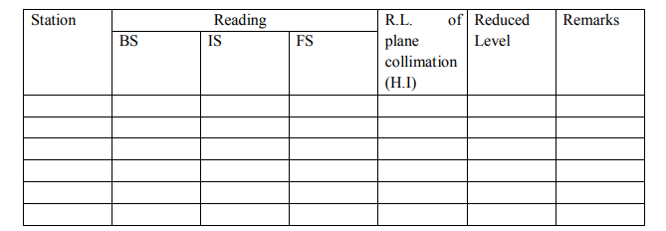

Arithmetical check: The difference between the sum of the back sights and the sum of the fore sights should be equal to the difference between the last and first reduced levels.

i.e. ∑B.S - ∑ F.S. = LAST R.L –FIRST R.L

2) The Rise and fall system In this system, there is no need to determine R.L. of plane of collimation .The difference of level between consecutive points are obtained as described below.

1) Determine the difference in staff readings between the consecutive points comparing each point after the first with that immediately preceding it.

2) Obtained the rise or fall from the difference of their staff reading accordingly to the staff reading at the point is smaller or greater than that of proceeding point. Find out the reduced level of each point by adding the rise to or subtracting fall from the R.L. of a proceeding point.

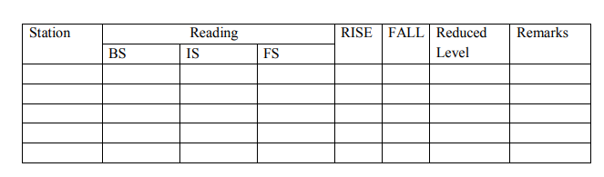

**Arithmetic check: -** The difference between the sum of back sight

Fore sight= difference between the sum of rise and the sum of fall = the difference between the last R.L. and the first R.L.

∑B.S-∑F.S =∑RISE -∑FALL =LAST RL- FIRST RL

Inverted staff reading When the B.M of staff station is above the line of collimation (or line of sight) the staff is held inverted on the point and reading is taken .This reading being negative is entered in the level field book with minus sign, or to avoid confusion, ‘Staff inverted’ should be written in the remarks column against the entry of the reading

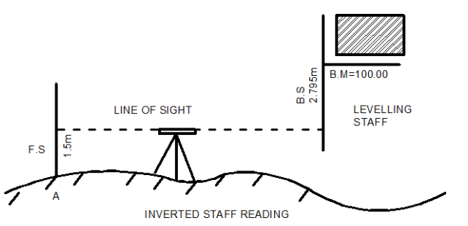

The results are tabulated as below:

|  |  |  |  |  |  |
| --- | --- | --- | --- | --- | --- |
| BS | IS | FS | HI | RL | REMARK |
|  |  |  |  |  |  |

When the reading on the inverted staff is a foresight or intermediate sight .it should also be recorded in field book with minus sign

The R.L. of such points may be worked at as:

R.L.of the point (where the inverted staff is held) =R.L. of H.I +F.S. or I.S.reading

**RESULT:-** The various reduced levels are calculated by rise and fall method and by using height or plane of collimation method and are shown in observation table.

**Advance Surveying Lab (CE-605)**

**Civil Engineering**

**EXPERIMENT NO.5**

**Fixing bench mark with respect to temporary bench mark with dumpy level by fly levelling and check levelling.**

**Date of conduction:-**

**Date of submission:-**

**Submitted by other members:-**

**1.**

**2.**

**3.**

**4.**

**5.**

**Group no:-**

**Signature**

**Name of faculty in charge:**

**Name of Technical Assistant:**

**AIM:-**Fixing bench mark with respect to temporary bench mark with dumpy level by fly leveling and check levelling.

**Apparatus:-**Dumpy level, levelling staff, tripod stand, arrows, pegs

**Theory:-**

**Fly levelling**: – It is a very approximate from of levelling in which distances are not measured and sights are taken as large as possible. in this method a line of levels is run to determine approximately reduced levels of the points carried out with more rapidly and less precision.

**Check levelling:** The main purpose of this type of levelling is to check the values of the reduced levels of the bench marks already fixed. In this method only back sight and foresight are taken. There is no need of intermediate sights. However great care has to be taken for selecting the change points and for taking reading on the change points because the accuracy of levelling depends upon these.

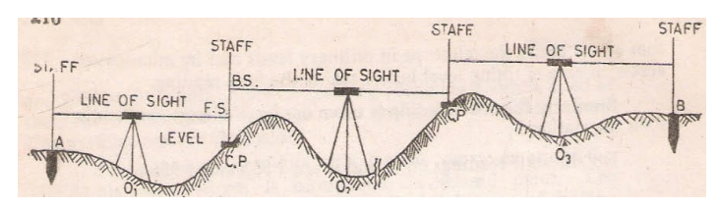

**PROCEDURE:-**

1. Let A and B the two points as shown in figure They are too for apart .The position of each set up of level should be so selected that the staff kept on the two points is visible through the telescope.
2. Let O1, O2, O3 be the positions of the level to be setup. Choose the change points 1,2 etc. on a stable ground so that the position of the level should be midway between the two staff reading to avoid error due to imperfect adjustment of the level.
3. Now setup the level at O1 take the reading on the staff kept vertically on A with bubble central. This will be a back sight and R.L of the A is is to assumed or say known. Record these values in the same line in the level book.
4. Now select the position of C.P (1) so that the distance of it from O1 is approximately equal to that O1A
5. With the bubble in the centre take the reading of the staff held vertically over the change point. This will be a fore sight and book this value in the level book on the next line in the column provided.
6. Now shift the level to O2 and set up it there carefully, with the bubble in the centre take reading on the staff kept vertically as the fore sight over C.P(1). This will be a back sight, book it in the same line as the fore sight already recorded in the column provided.
7. Select another CP (2) on the stable ground as before so that station O2 is approximately midway between C.P (1) and C.P (2).
8. With the bubble central, take the reading on the staff kept vertically over the CP2.This will be fore sight and book it in the level book page in next line.
9. Repeat the process until the point B.M reached .The last reading will be a foresight
10. Now find out the reduced levels by height of instrument method or by rise and fall method.
11. Complete the remakes column also. Apply the arithmetical check

## ****Observation table:-****

## C:\Users\CIVIL-PC\Desktop\hgkjmjh.png

## ****RESULT:-****

The difference of level betw

een the point be equal to R.L of the last point minus the R.L at the B.M is found to be ——

**Advance Surveying Lab (CE-605)**

**Civil Engineering**

**EXPERIMENT NO.6**

**Measurement of vertical Angles with Theodolite**

**Date of conduction:-**

**Date of submission:-**

**Submitted by other members:-**

**1.**

**2.**

**3.**

**4.**

**5.**

**Group no:-**

**Signature**

**Name of faculty in charge:**

**Name of Technical Assistant:**

**AIM:-** Measurement of vertical Angles with Theodolite

**APPARATUS: -** Theodolite, three ranging rods,

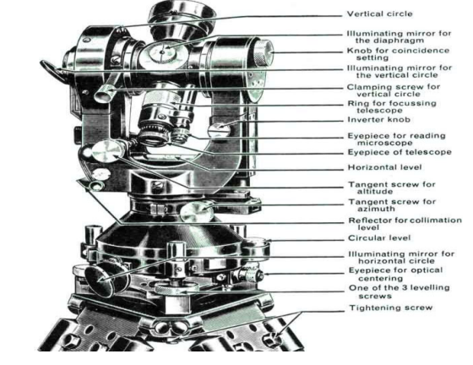

Fig.1- Transit Theodolite

**THEORY:-** Theodolite is an instrument designed for the measurement of horizontal and vertical angle. It is most precise method it is also used for laying of horizontal angles Locating points on line prolonging the survey line establishing the gradient, determination of difference in the elevation setting out curve .Theodolite are of two types transit and non transit. Transit theodolite is commonly used now a day’s .in transit theodolite telescope can be revolved a complete revolution about its horizontal axis in a vertical plane. a transit theodolite consists of essential part.

Tripod. The head comprises of two parts

a) A levelling foot screws for levelling the instrument i.e. for marking vertical axis truly vertical.

b) A movable head or cantering arrangement for cantering the vertical axis accurately over a station point.

2) A lower level circular horizontal metal plate: It carries a circular graduated arc. The lower plate is attached to a vertical metal spindle (outer axis) which works in vertical bearing and a form a part of levelling head. It may be graduated in degree and half degree or a degree 1/3 of degrees .the upper plate carries an index and vernier or micrometer towards fine reading on gradated horizontal circle .the upper plate carries standard use of for supporting the telescope and the spirit level used for levelling the instrument.

3) A telescope: The telescope is pivoted between the standard at right angles to the horizontal axis. It can be rotated about its horizontal axis in a vertical plane. The telescope is provided with the focusing screw, Clamping screw and tangent screw.

4) A circular graduated are carried on vertical circle: It is attached to the horizontal axis of the telescope, it is usually divided into 4 quadrants, but in some instruments it is graduated continuously from 0-3600.the graduation in each quadrant are numbered from 0-900 in opposite direction. The subdivisions of vertical circle are similar to those of vertical circle.

MESURMENT OF VERTICAL ANGLE A vertical angle is the angle between the inclined line of sight to an object and the horizontal. It may be an angle of elevation or on angle of depression according as the instrument. To measure angle of elevation or depression LOM shown in fig. proceed as follows:

1) Set up the theodolite at station point O and level it accurately with reference to the altitude level.

2) Set vertical verniers C and D exactly to zero by using the vertical circle clamp and tangent screw, while the altitude level should remain in the centre of its run. Also the face of the theodolite should be left.

3) Release the vertical circle clamp screw and rotate the telescope in vertical plane so as to bisect the object M. tighten the vertical circle clamp and exactly bisect the object by slow motion screw.

4) Read both verniers C and D. the mean of the tow readings gives the value of the required angle.

5) Similar observation may be made with other face. The average of the tow values thus obtained gives the value of the required angle which is free from instrumental errors.

6) Similarly the angle of depression can be measured following the above steps.

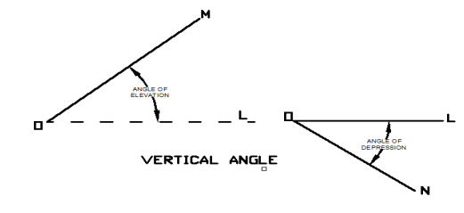

Fig.2- Vertical Angle

To measure the vertical angle between two points L and M Sometimes it is required to measure vertical angle between two points L and M. There can be three possibilities. (a) One point is above the line of sight and the other is below the line of sight then angle LOM as shown in fig will be equal to

(b) Both the points are above the line of sight. Then the angle LOM (Refer Fig 2)

(c) Both the points are below the line of sight, then the angle LOM= (Refer Fig 3)

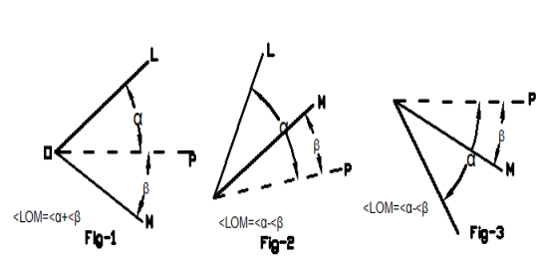

To measure the angle between two points L and M proceed as follows

1) Set the theodolite at station point O and accurately level it.

2) Bisect the flag at L as explained already and take the reading on the verniers C and D. Calculate the mean angle.

3) Bisect the flag at M as before and take the reading on the verniers C and D. Calculate the mean angle.

between points L and M as shown in the figure (4)

**Observation table:-**

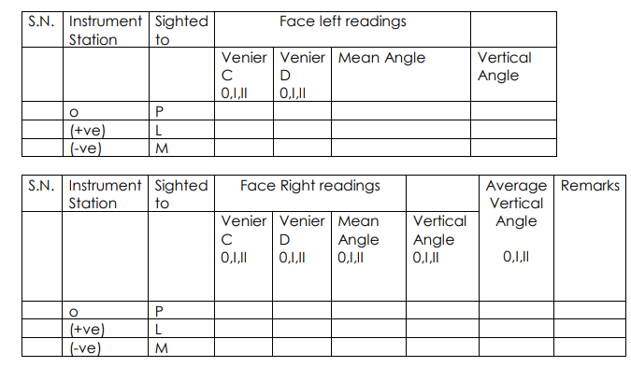

**Result:** -The average value of vertical is found to be---------------------.

**Advance Surveying Lab (CE-605)**

**Civil Engineering**

**EXPERIMENT NO.7**

**Determination of horizontal distance between two inaccessible points with theodolite APPARATUS: - Theodolite, three ranging rods**

**Date of conduction:-**

**Date of submission:-**

**Submitted by other members:-**

**1.**

**2.**

**3.**

**4.**

**5.**

**Group no:-**

**Signature**

**Name of faculty in charge:**

**Name of Technical Assistant:**

**AIM: -**Determination of horizontal distance between two inaccessible points with theodolite **APPARATUS:-** Theodolite, three ranging rods

**Theory: -** Traverse computation the latitude of the line may defined as the distance measured parallel to an assumed meridian direction (i.e. true meridian, magnetic meridian or any other reference direction).

The departure of a line may define as the distance measured parallel to line perpendicular to the meridian.

The latitude (L) of a line is positive (+ve) when measured northward or upward and is termed as Northing, the latitude of a line (-ve) when measured southward or downward and termed as southing similarly the departure (D) of a line is positive (+ve) when measured Eastward or to the right and is known as Easting.

The departure of a line is negative (-ve) when measured Westward or to left and is known as Westing

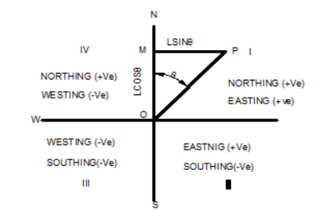

Refer to fig suppose the length of the line OP=L and bearing of the line θ, then Departure of the line =lsinθ Thus to find the latitude and departure of the line , it is essential to convert the bearing (W.C.B) to reduce bearing (R.B); because the sign of latitude and departure depends upon the reduced bearing i.e. the first letter N or S determine the sign of the latitude and E or W determine the sign of the departure.

The following table gives the sign of latitude and departure.

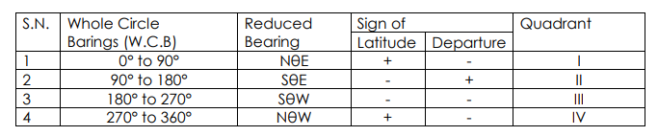

Problem: - the distance between two inaccessible points P and Q, the theodolite is set up at two stations A& B 1000m apart and the following angles were observed.;

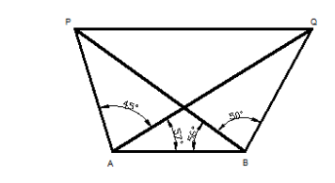

<PAQ=45°; <PAQ=57°; <PBA=50°; <PBQ=50°; The The distance of two inaccessible point PQ is calculated by It is clear that lines PA, AB, BQ, and QP from closed traverse. The latitude and departure of lines PA,AB and BQ can be determine by calculating their length and bearing first.

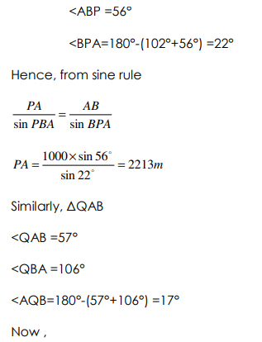

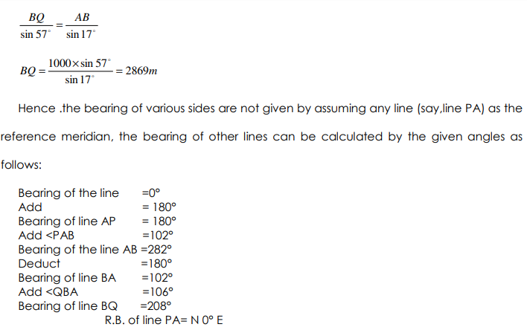

R.B. of line BQ= S28°W

The latitudes and departure (or consecutive coordinates) can be calculated as given below;

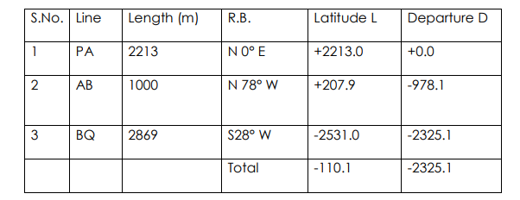

**Result: -** Length of line PQ=C:\Users\CIVIL-PC\Desktop\hjhjjh.png

**Advance Surveying Lab (CE-605)**

**Civil Engineering**

**EXPERIMENT NO.8**

**Locating given building by theodolite traversing**

**Date of conduction:-**

**Date of submission:-**

**Submitted by other members:-**

**1.**

**2.**

**3.**

**4.**

**5.**

**Group no:-**

**Signature**

**Name of faculty in charge:**

**Name of Technical Assistant:**

**AIM:-** Locating given building by theodolite traversing (One full size drawing sheet)

**APPARATUS: -** Theodolite, three ranging rods

**THEORY:** -Theodolite Traversing: A traverse survey is one in which the framework consists of a series of connected lines, the lengths and direction of which are measured with the help of tape or chain and an angle measuring instrument. When the lines from a circuit which ends at the starting point, the survey is termed a closed traverse, if the circuit does not close, the traverse os known as open one. The closed traverse is suitable for wide areas and for locating the boundaries of the lakes, wood etc., where an open traverse is carried out in the of long strips of country as in the case of canal, road , railway etc. In theodolite traversing, theodolite is used for measurement of angles or tape or chain, preferable, steel tape is used for linear measurement .This method is applied for accurate and precise survey.

Method of traversing the method of measuring the angle and bearing of a traverse may be divided into classes:

a) Those in which the angle at different stations is measured directly and the bearing subsequently calculated from the measured angles and the given bearing of an initial line

b) By direct observation of bearing of different survey lines by a theodolite.

A) theodolite Traversing by Direct Observation of Angle: - In this method, horizontal angles measured at different stations may be either,

Ii. Defection Angle

1. Traversing by the method of included angles: - In a closed traverse included angles can be measured by running a traverse in clockwise or counterclockwise direction. The common practice is to run a closed traverse in counterclockwise direction, but it is well to adhere to a regular of routine of measuring angles. Generally interior angles are obtained it the traverse is run anticlockwise and exterior ones when it is run clockwise as shown in the fig 1&2.

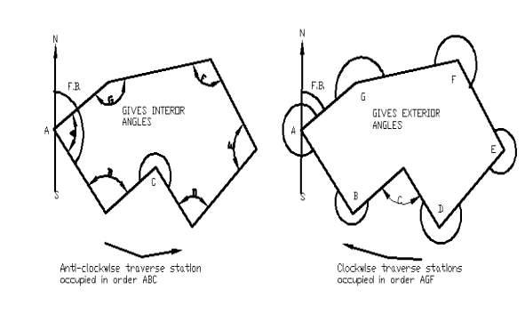

**fig 1&2.**

The angle may be measured by the repetition method and the observation should be taken with both the faces and also by reading both the verniers. Then averaging the value of each angle should be calculated. It will ensure desired degree of accuracy and removal of most of the instrumental errors.

Procedure: - In running a traverse ABCDEFG as shown in figure, set up the thedolite over the station A and level it accurately. Observe the magnetic bearing at the line AB and measure the included angle GAB as usual.

Shift the theodolite to each of the successive stations B, C, D, E----- (in anticlockwise direction) and repeat the process to measure each of the angle ABC, BCD, CDE etc. Also measure the length of the line AB, BC, CD and so on by means of a steel tape if possible and take necessary offsets to locate different details on each of the survey line. The whole work should be recorded carefully in the field note book. In open traverse say LMOP as shown in Fig.

The theodolite is setup at starting station L and fore bearing of line LM is taken. The theodolite is then shifted M, O and the direct angles such as LMO, MOP---- are measured in the forward direction. Length of each line is measured and necessary offsets are taken to locate different details on each of the survey line.

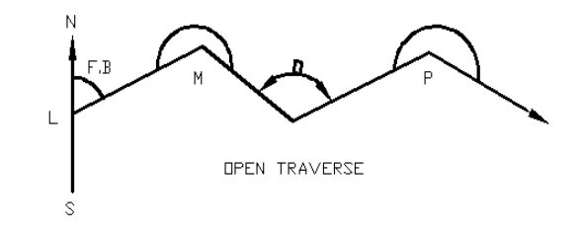

**Fig.3- open Traverse**

This method of traversing is more suitable in surveys for railway, roads, pipeline etc. in which a series of traverse lines may make small deflection angles with each other. In measuring deflection angles having observed the bearing at the starting station ‘L’ Set the theodolite at each of station such as M,N,O,Q. Bisect the back stations using lower clamp and its tangent screw.

The vernier may be set to zero or the initial reading may be taken. The theodolite is transited and the forward station is bisected with upper clamp screw and the tangent screw.

The verniers are again read, the difference between the first set of reading and the second gives the angle of defection. The measurement is either right or left handed and this direction must be most carefully noted in the field book. Chaining is done in the usual manner.

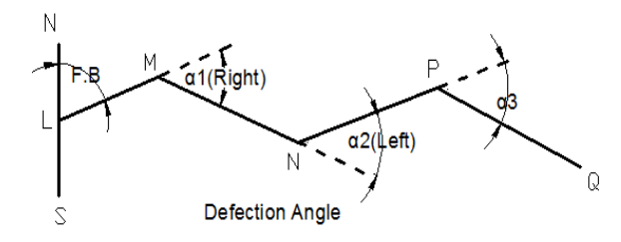

**Fig.4- Defection Angle**

Traverse computation are usually are done in the tabular from the most commonly used tabular from is known as Gale’s traverse table. The steps followed are as under for computing the table.

1) Find out the sum of the entire observed, interior or exterior angle it should be (2n+4) right angle where n= number of sides of traverse.

2) If the sum is not equal to (2n+4) right angles for exterior or interior angles apply the necessary correction to all the angle so that the sum of the corrected angles should be exactly equal to (2n± 4) right angles.

3) Find out the whole circle bearing (W.C.B) of all other lines from the observed bearing of the first line and the corrected included angles. As a check the calculated bearing of the first line must be equal to observed bearing.

4) Convert the whole circle bearing to the reduced bearings and determine the quadrant in which they lie.

5) Calculate the latitude and departure of each line from the known length and the reduced bearing of the lines.

6) Find out the sum of all nothings and also of southing’s similarly of easting’s and wettings. Determine the difference if any between nothings and southing’s, also in easting’s and wettings.

7) Apply the necessary correction as per calculations to the latitudes and departures of each lines, so that the sum of nothings must be equal to sum of southing’s, also easting’s and westingsordinates of the line, so that they all are positive, the whole of the traverse thus lying in the first quadrant i.e. North-East quadrant.

**Gale’s Traverse Table is shown in table:-**

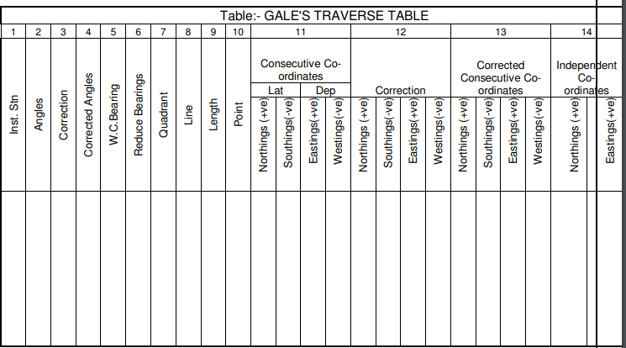

**Fig.5-Gale’s Traverse Table**

**Result: -** 1) Closing Error =√ (∑L) 2+ (∑D) 2

1. Reduced bearing (θ) of the closing error =Tan-1∑D/∑L

**Advance Surveying Lab (CE-605)**

**Civil Engineering**

**EXPERIMENT NO.9(a)**

**To Perform complete survey with Total Station**

**TRAVERSING USING TOTAL STATION**

**Date of conduction:-**

**Date of submission:-**

**Submitted by other members:-**

**1.**

**2.**

**3.**

**4.**

**5.**

**Group no:-**

**Signature**

**Name of faculty in charge:**

**Name of Technical Assistant:**

**1.1 OBJECTIVE: -**

To form a closed traverse using total station

**1.2 RESOURCES: -**

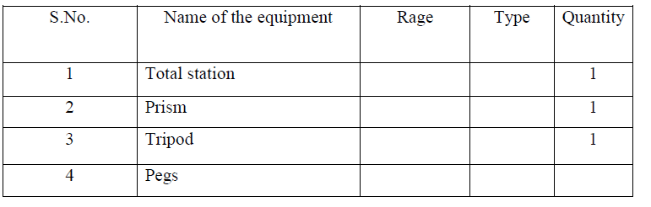

**1.3 PERCAUTIONS**

**g) Temporary adjustment for total station**

**h) Leveling and centering**

**i) Focusing adjustment**

**1.4 PROCEDURE :-**

1. Fix the total station over a station and level it

2. Press the power button to switch on the instrument.

3. Select MODE B -------> S function------->file management------>create(enter a name)------->accept

4. Then press ESC to go to the starting page

5. Then set zero by double clicking on 0 set(F3)

6. Then go to S function ------> measure-----> rectangular co-ordinate---->station --- >press enter.

7. Here enter the point number or name, instrument height and prism code.

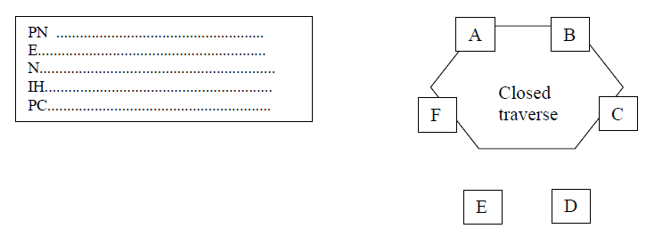

8. Then press accept (Fs)

9. Keep the reflecting prism on the first point and turn the total station to the prism ,focus it and bisect it exactly using a horizontal and vertical clamps.

10. Then select MEAS and the display panel will show the point specification

11. Now select edit and re-enter the point number or name point code and enter the prism height that we have set.

12. Then press MEAS/SAVE (F3) so that the measurement to the first point will automatically be saved and the display panel will show the second point.

13. Then turn the total station to second point and do the same procedure.

14. Repeat the steps to the rest of the stations and close the traverse

15. Now go to S function----> view/edit----graphical view.

16. It will show the graphical view of the traverse.

**DIAGRAM:-**

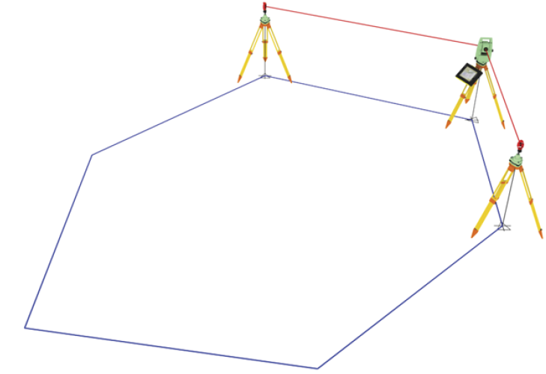

**1.5 Calculation :**

Select S function---> calculation---> 2D surface----> All------> accept

**1.6 RESULTS :-**

Select S function---> calculation---> 2D surface----> All------> accept This will give the area of the closed traverse. Area of the closed traverse is calculated.

**Advance Surveying Lab (CE-605)**

**Civil Engineering**

**EXPERIMENT NO.9(b)**

**To Perform complete survey with Total Station**

**CONTOURING USING TOTAL STATION**

**Date of conduction:-**

**Date of submission:-**

**Submitted by other members:-**

**1.**

**2.**

**3.**

**4.**

**5.**

**Group no:-**

**Signature**

**Name of faculty in charge:**

**Name of Technical Assistant:**

**1.1 OBJECTIVE:-** Counter plan of given area (One full size drawing sheet) using total station.

**1.2 RESOURCES: -**

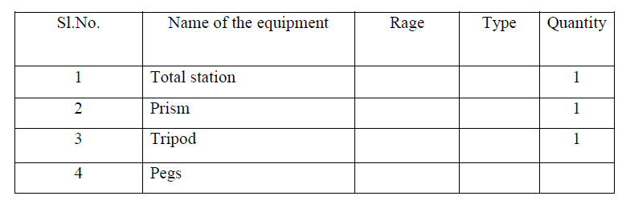

**1.3 PERCAUTIONS**

**a) Temporary adjustment for total station**

**b) Leveling and centering**

**c) Focusing adjustment**

**1.4 PROCEDURE :-**

The elevation and depression and the undulations of the surface of the ground are shown as map by interaction of level surface with by means of contour line. A contour may be defined as the line of intersection of a level surface with the surface of the ground.

1. Fix the total station over a station and level it

2. Press the power button to switch on the instrument.

3. Select MODE B -------> S function------->file management------>create (enter a name)------->accept

4. Then press ESC to go to the starting page

5. Then set zero by double clicking on 0 set (F3)

6. Then go to S function ------> measure-----> rectangular co-ordinate---->station --- >press enter.

7. Here enter the point number or name, instrument height and prism code.

8. Then press accept (Fs)

9. Adopt Cross section method for establishing the major grid around the study area.

10. Project suitably spaced cross sections on either side of the centre line of the area.

11. Choose several points at reasonable distances on either side.

12. Keep the reflecting prism on the first point and turn the total station to the prism, focus it and bisect it exactly using horizontal and vertical clamps. 13. Then select MEAS and the display panel will show the point specification

14. Now select edit and re-enter the point number or name point code and enter the prism height that we have set.

15. Then press MEAS/SAVE (F3) so that the measurement to the first point will automatically be saved and the display panel will show the second point. 16. Then turn the total station to second point and do the same procedure.

17. Repeat the steps to the rest of the stations and get all point details.

18. Plot cross section lines to scale and enter spot levels.

19. The points on the chosen contours are interpolated assuming uniform slope between adjacent points and join them by a smooth line.

**1.5 DIAGRAM: -**

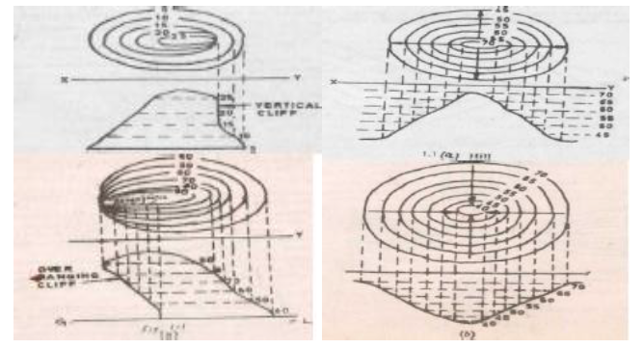

**1.6 Calculation :**

Select S function---> calculation---> 2D surface----> All------> accept

**1.7 RESULTS :-**

Select S function---> calculation---> 2D surface----> All------> accept . The contour of given land is drawn in the sheet.

**Advance Surveying Lab (CE-605)**

**Civil Engineering**

**EXPERIMENT NO.9(c)**

**To Perform complete survey with Total Station**

**DETERMINATION OF REMOTE HEIGHT USING TOTAL STATION**

**Date of conduction:-**

**Date of submission:-**

**Submitted by other members:-**

**1.**

**2.**

**3.**

**4.**

**5.**

**Group no:-**

**Signature**

**Name of faculty in charge:**

**Name of Technical Assistant:**

**1.1 OBJECTIVE: -**

To find the height of a remote point using total station.

**1.2 RESOURCES: -**

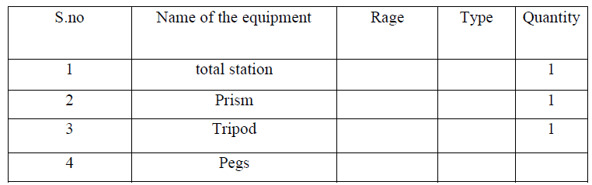

**1.3 PERCAUTIONS**

**a) Temporary adjustment for total station**

**b) Leveling and centering**

**c) Focusing adjustment**

**1.4 PROCEDURE :-**

1. Fix the total station over a station and level it

2. Press the power button to switch on the instrument.

3. Select MODE B -------> S function------->file management------>create(enter a name)------->accept

4. Press ESC to go to the starting page

5. Then set zero by double clicking on 0 set(F3)

6. Then go to S function ------> measure-----> rectangular co-ordinate---->station --- >press enter.

7. Here enter the point number or name, instrument height and prism code.

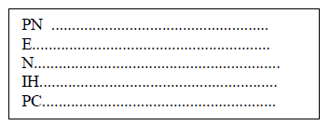

8. Then press accept (Fs)

9. Setup a reflector vertically beneath the point, the height of which is to be determined.

10. Enter the reflector height, target to it, and measure the distance.

11. Target the high point.

12. The height difference H between the ground point and the high point is now calculated and displayed at the touch of a button

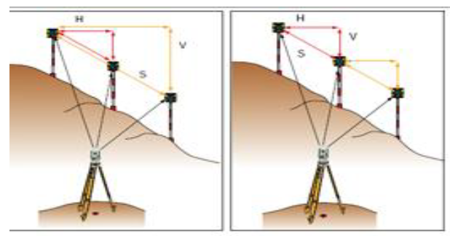

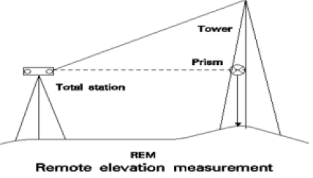

**1.3 Calculation :**

Select S function---> calculation---> 2D surface----> All------> accept

**1.4 RESULTS :-**

Select S function---> calculation---> 2D surface----> All------> accept Height of a remote point using total station is obtained

**Advance Surveying Lab (CE-605)**

**Civil Engineering**

**EXPERIMENT NO.9(d)**

**To Perform complete survey with Total Station**

**STAKE-OUT USING TOTAL STATION**

**Date of conduction:-**

**Date of submission:-**

**Submitted by other members:-**

**1.**

**2.**

**3.**

**4.**

**5.**

**Group no:-**

**Signature**

**Name of faculty in charge:**

**Name of Technical Assistant:**

**1.1 OBJECTIVE: -**

To find a specific point in the field using Total Station

**1.2 RESOURCES: -**



**1.3 PERCAUTIONS**

**a) Temporary adjustment for total station**

**b) Leveling and centering**

**c) Focusing adjustment**

**1.4 PROCEDURE:-** Place the total station in the spot from which you want to stake out points after you have finished entering the coordinates for the area into the total station's internal memory.

1. Make sure that the total station is level and on secure, even ground before continuing.

2. Press the "Power" button to turn on the instrument.

3. Press the "Menu" button and use the navigation arrows to move down to the "Stake Out" menu option. Press the "Select" button to enter the stake out menu.

4. Select the method to stake out the point. Select "XY" to stake out by coordinates which will be the most common method.

5. Press the "Yes" button to continue the process using the coordinates on the screen.

6. If the coordinates are incorrect, press the "No" button to try again.

7. In the next screen, use the keypad to enter the coordinates or distances and press the "OK" button to measure.

8. The results will be displayed on the following screen.

**DIAGRAM:-**

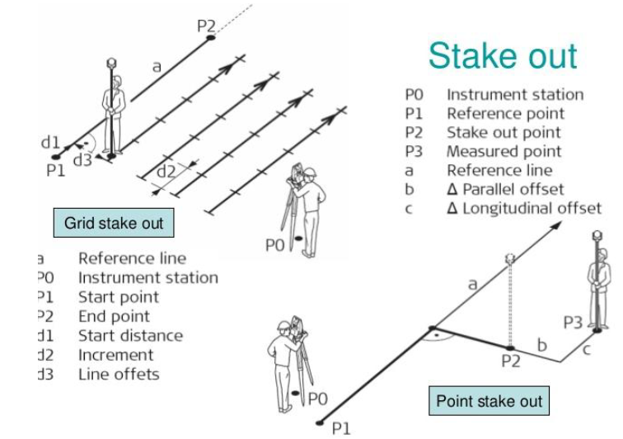

**1.2 Calculation :**

Select Stake function---> calculation---> 2D surface----> All------> accept

**1.3 RESULTS :-**

Select Stake function---> calculation---> 2D surface----> All------> accept

Distance, gradient, diff, height between two inaccessible points using Total Station is calculated.

**Advance Surveying Lab (CE-605)**

**Civil Engineering**

**EXPERIMENT NO.9(e)**

**To Perform complete survey with Total Station**

**DISTANCE, GRADIENT, DIFF, HEIGHT BETWEEN TWO INACCESSIBLE POINTS USING TOTAL STATION**

**Date of conduction:-**

**Date of submission:-**

**Submitted by other members:-**

**1.**

**2.**

**3.**

**4.**

**5.**

**Group no:-**

**Signature**

**Name of faculty in charge:**

**Name of Technical Assistant:**

**1.1 OBJECTIVE:-**

To find the Distance, gradient, diff, height between two inaccessible points using Total Station.

**1.2 RESOURCES: -**



**1.3 PERCAUTIONS**

**a) Temporary adjustment for total station**

**b) Leveling and centering**

**c) Focusing adjustment**

**1.4 PROCEDURE :-**

1. Fix the total station over a station “O” and level it

2. Press the power button to switch on the instrument.

3. Select MODE B -------> S function------->file management------>create(enter a name)------->accept

4. Press ESC to go to the starting page

5. Then set zero by double clicking on 0 set (F3)

6. Then go to S function ------> measure-----> rectangular co-ordinate---->station --- >press enter.

7. Here enter the point number or name, instrument height and prism code.

8. Select two inaccessible points “P” and “Q” between which the distance, difference in height and gradient is to be measured.

9. Position a reflector pole on point “P” and enter the instrument height i and the target height t1 (prism).

10. Target the center of the prism and measure the distance.

11. Rotate the total station towards the other point “Q”, measure the distance between total station and point, measure the horizontal angle between two station points.

12. Enter the target height t2 (prism) for second point.

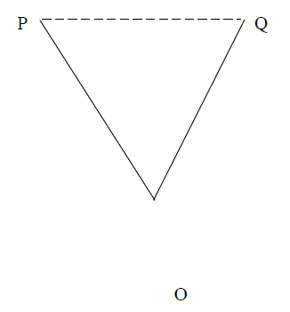

Level difference between P and Q

Gradient of line PQ = ----------------------------------------------

Horizontal distance PQ

**1.6 DIAGRAM: -**

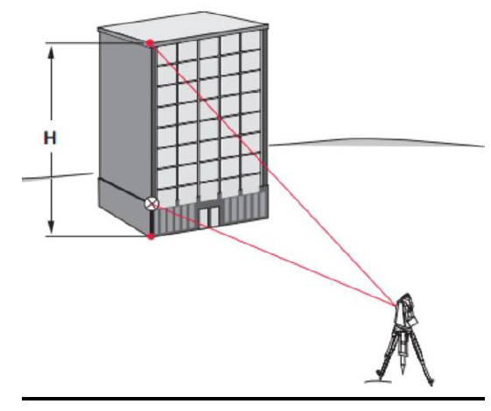

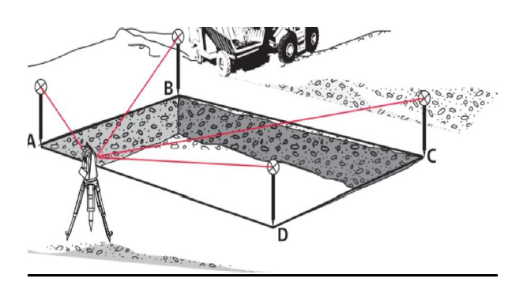

**1.8 RESULTS :-**

Select S function---> calculation---> 2D surface----> All------> accept

Distance, gradient, diff, height between two inaccessible points using Total Station is calculated.